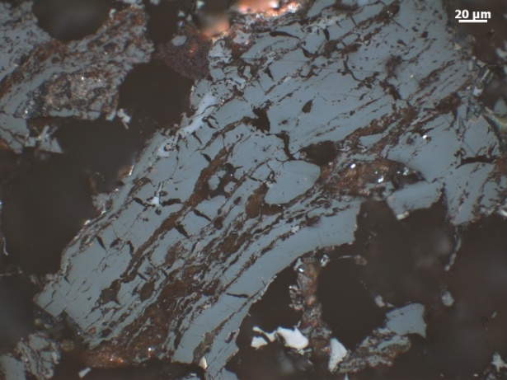 | 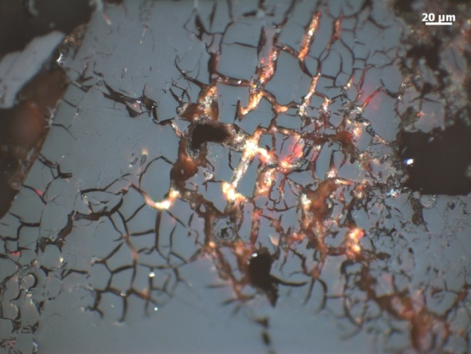
(a) Doc_0806 | (b) Doc_0823
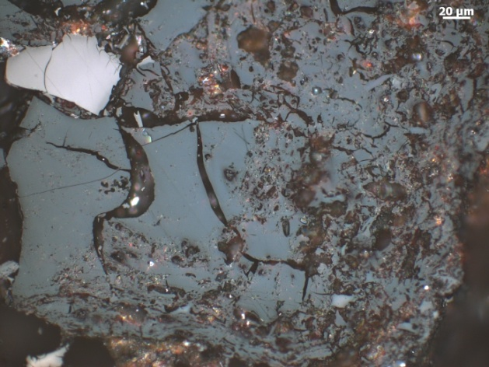 | 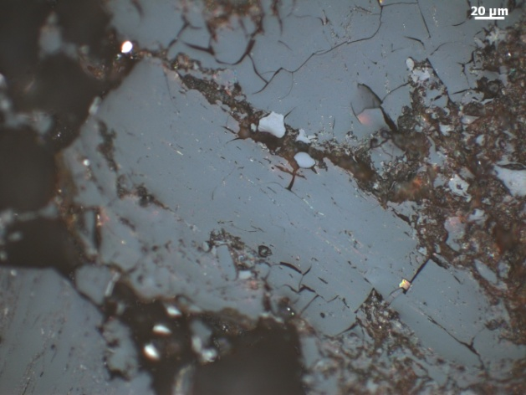
(c) | (d)
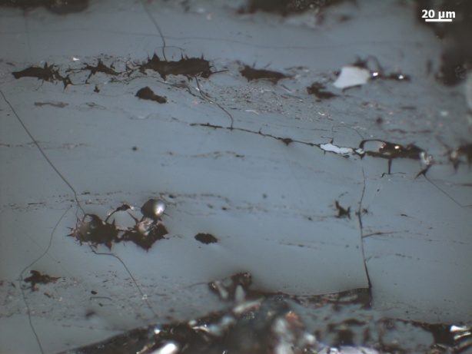 | 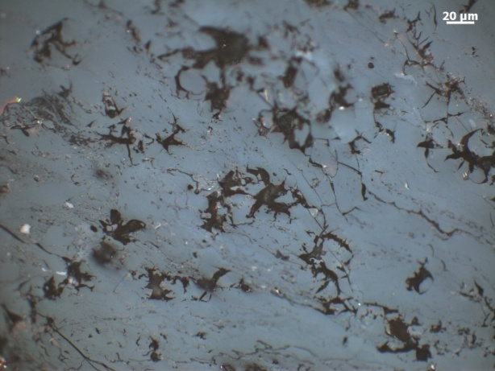
(e) | (f)
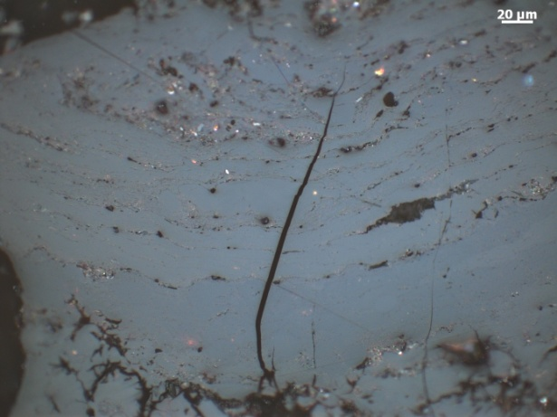 | 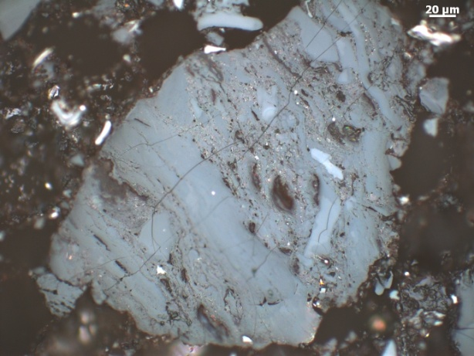

Plate 9. Photomicrographs showing the optical features of naturally in situ weathered coals in reflected light, oil immersion. Carboniferous high volatile bituminous coals A, north-central Texas. USA: (a),(b),(d),(e),(f) microcracks and microfissures. Photo-micrograph courtesy of P. Hackley (MSc. DIC), U.S. Geological Survey, National Center, Reston, USA.

