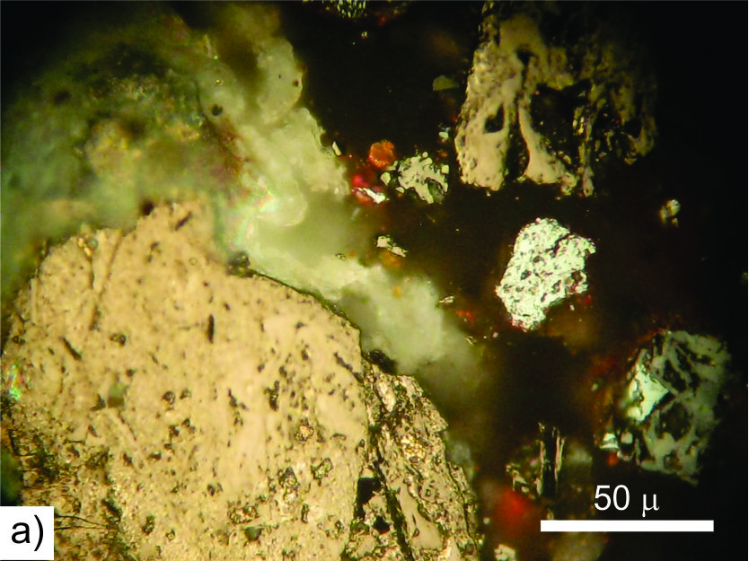 | 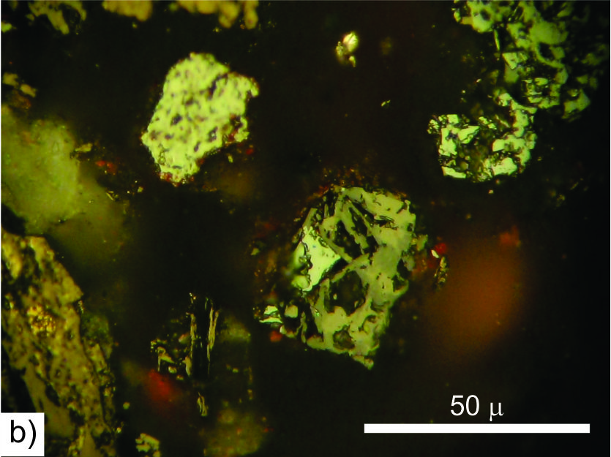
(a) | (b)
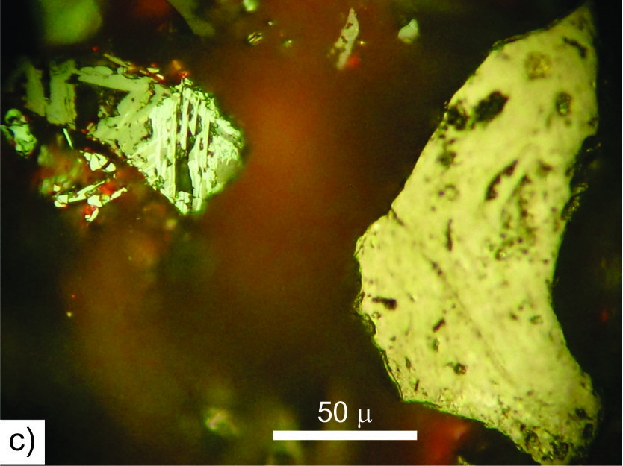 | 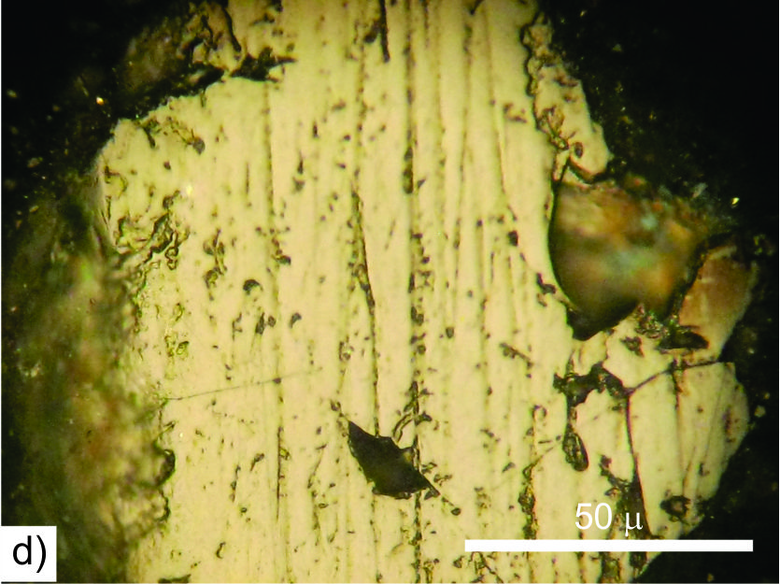
(c) | (d)
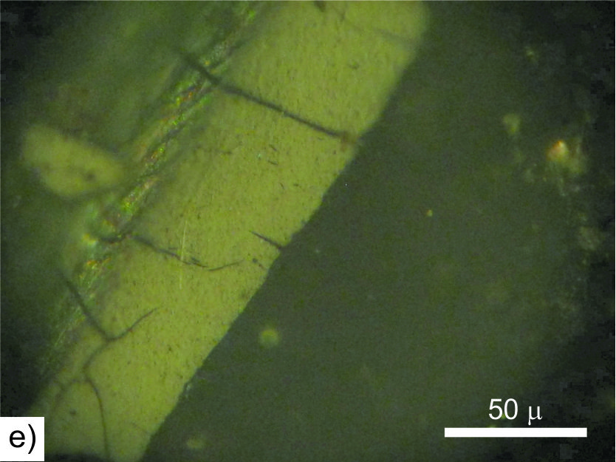 | 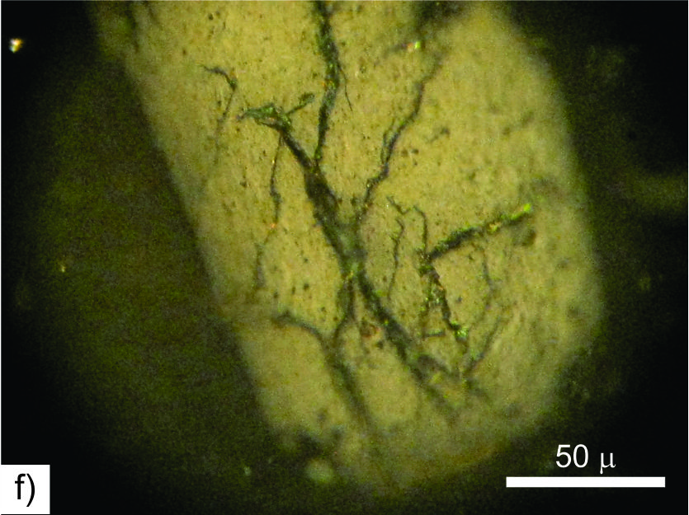
(e) | (f)
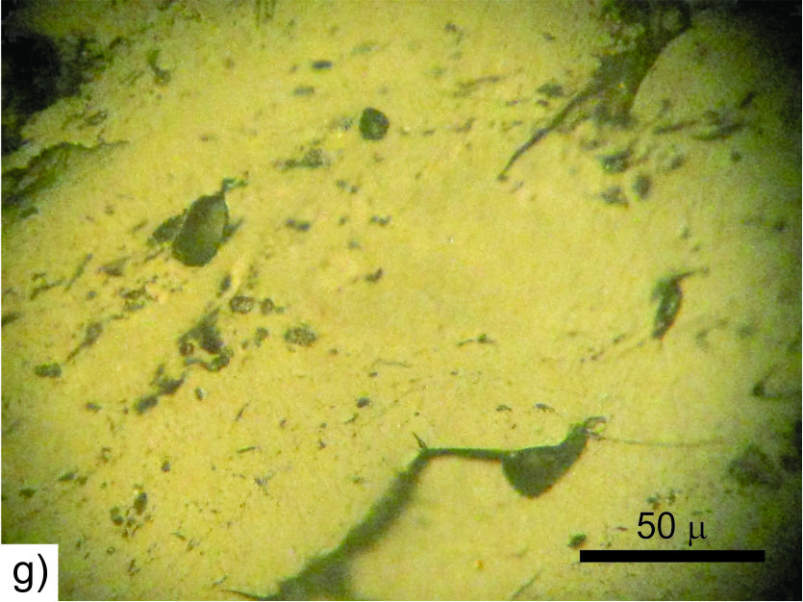 | 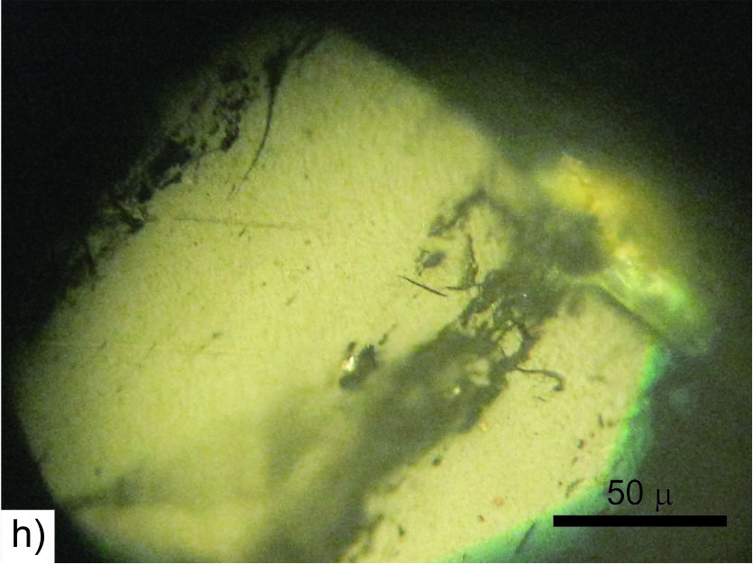

Plate 11. Photomicrographs showing the optical features of naturally in situ weathered coals in reflected light, oil immersion. Lower Jurassic semi-anthracite, Vrska Cuka deposit, Eastern Serbia: (a),(b),(c),(d) pitted surface; Middle Miocene lignite Cicevac Basin, Serbia: (e), (f) microcracks and microfissures; Carboniferous high volatile bituminous coal, Obradove Stolice Basin, Eastern Serbia: (g), (h) pitted surface, microcracks and microfissures; Photo-micrograph courtesy of Dr. Dragana Životić, University of Belgrade, Faculty of Mining and Geology, Belgrade, Serbia

