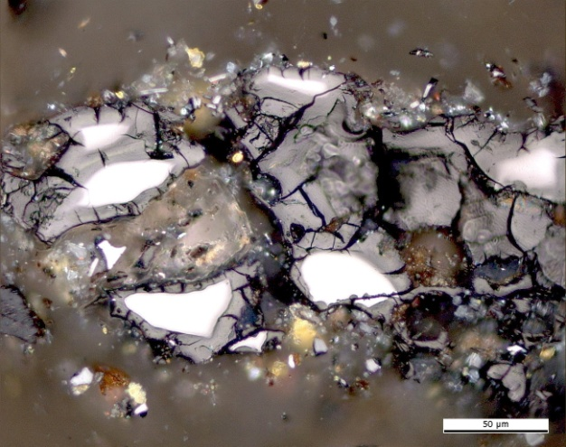 | 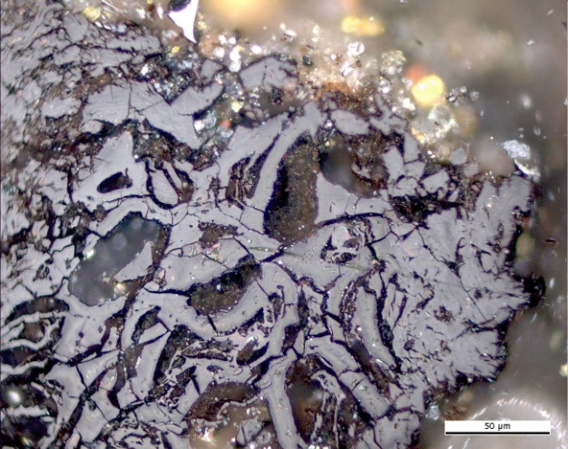
(a) | (b)
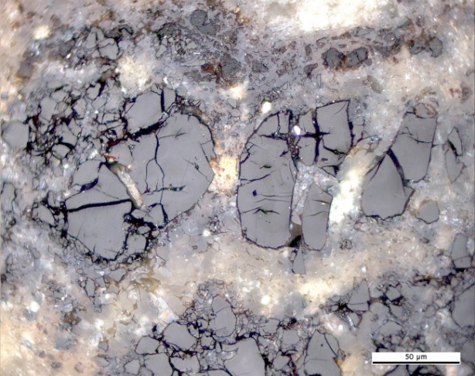 | 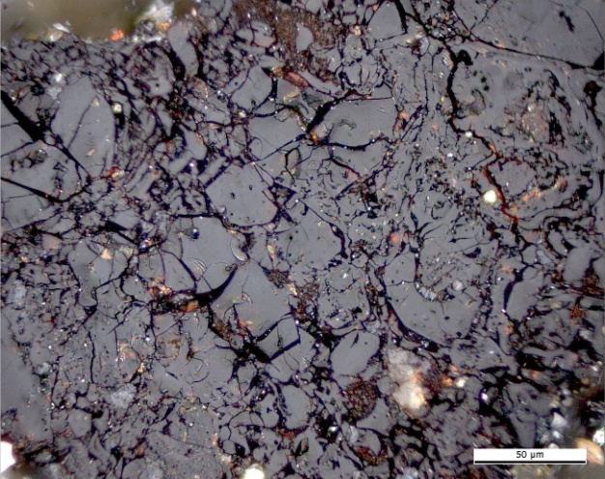
(c) | (d)
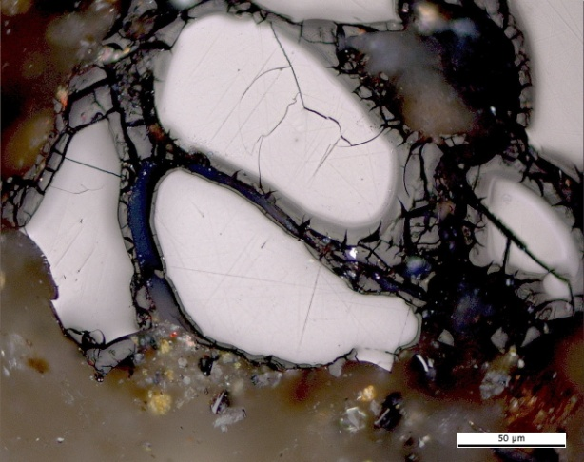
(e)

Plate 3. Photomicrographs showing the optical features of naturally in situ oxidised coals in Reflected light, oil immersion. Upper Permian low volatile bituminous coal A, Jordan: (a),(c) dark oxidation rim and shrinkage microcracks, (b),(c),(d),(e) microcracks. Photomicrograph courtesy of J. Kus (MSc. DIC), Geochemistry of Petroleum and Coal Section, Energy Resources, Mineral Resources Department, Federal Institute for Geosciences and Natural Resources. Hannover, Germany.

