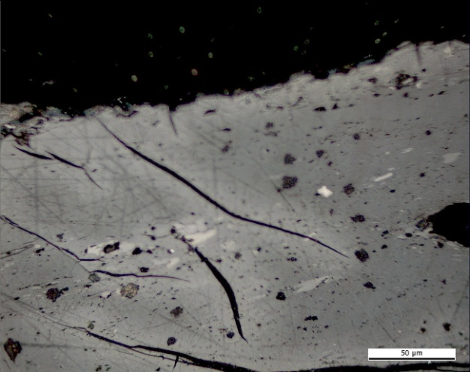 | 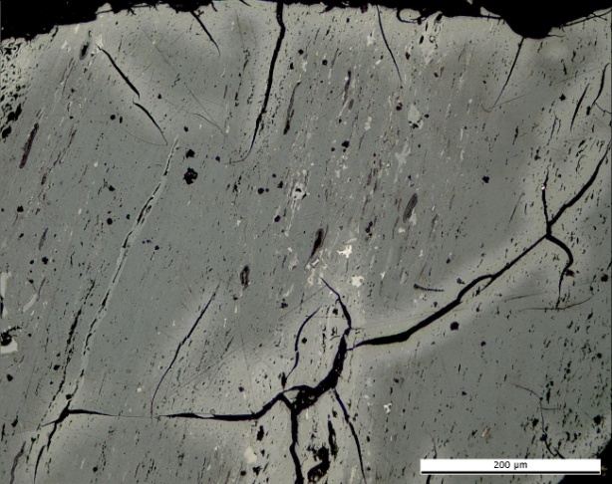
(a) | (b)
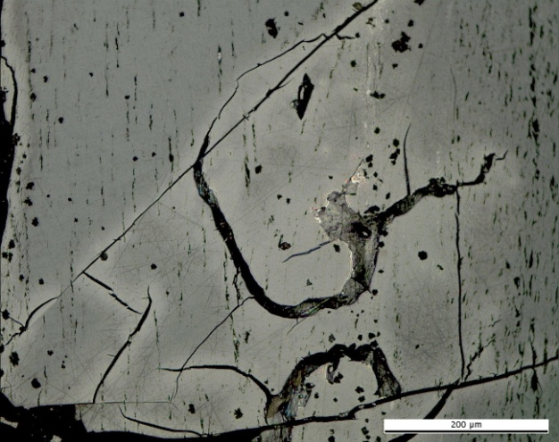 | 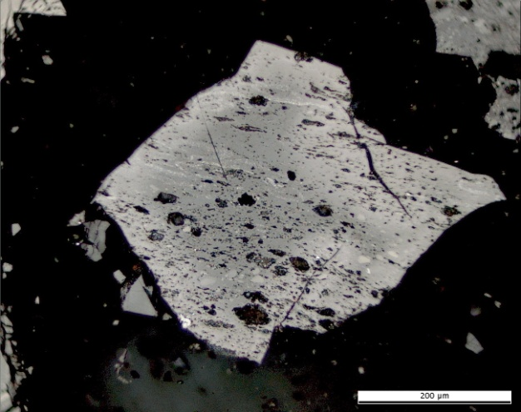
(c) | (d)
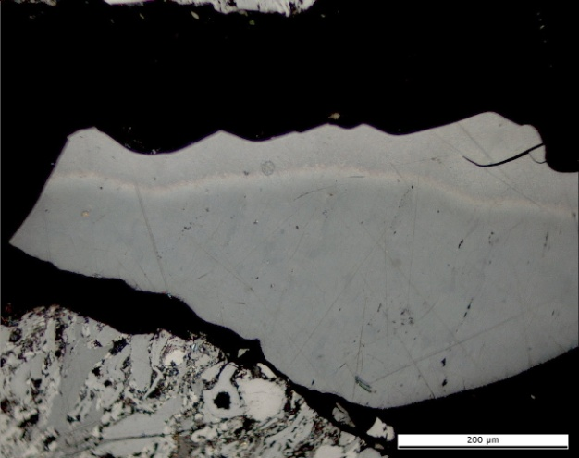 | 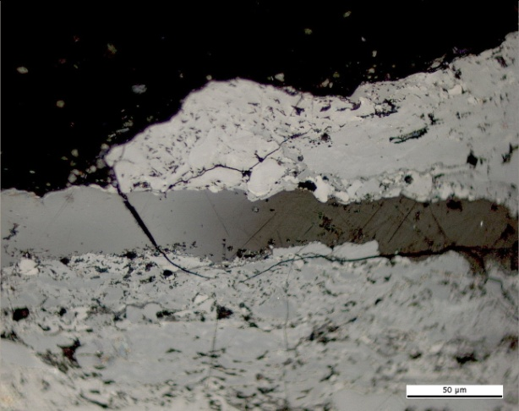
(e) | (f)
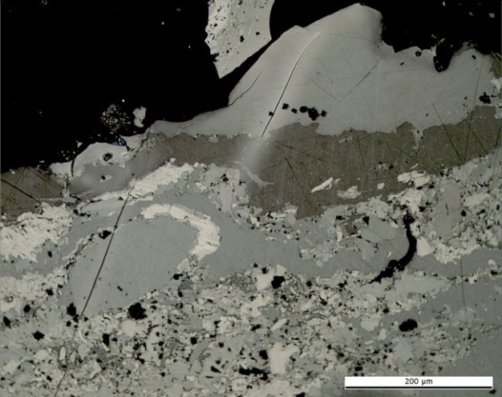 | 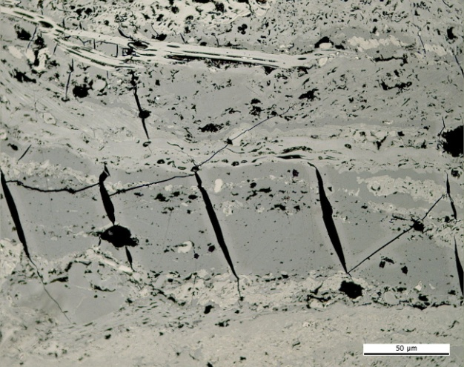
(g) | (h)

Plate 4. Photomicrographs showing the optical features of naturally in situ thermally oxidised coals in reflected light. Permian high volatile coal A. Wuda coal field, Inner Mongolia Province, China: (a) (b) (c) (d) pale oxidation rim and shrinkage microcracks (e) pale oxidation rim, (f),(g) pale oxidation rims along collotelinite and sporinite, (h) shrinkage microcracks. Photomicrograph courtesy of J. Kus (MSc. DIC), Geochemistry of Petroleum and Coal Section, Energy Resources, Mineral Resources Department, Federal Institute for Geosciences and Natural Resources. Hannover, Germany.

