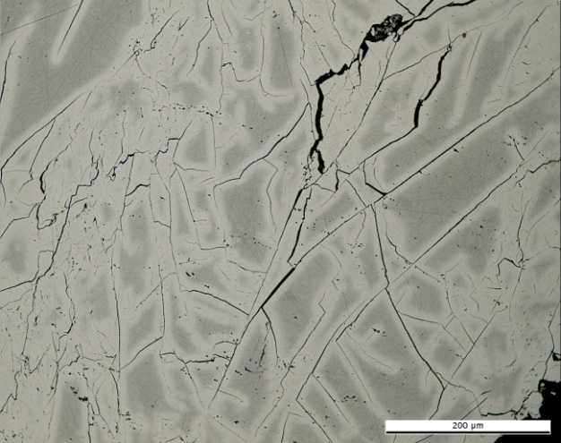 | 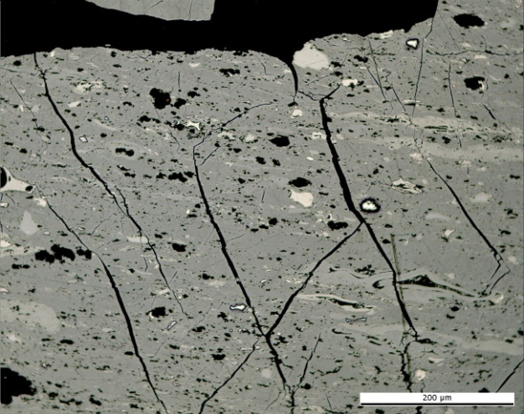
(a) | (b)
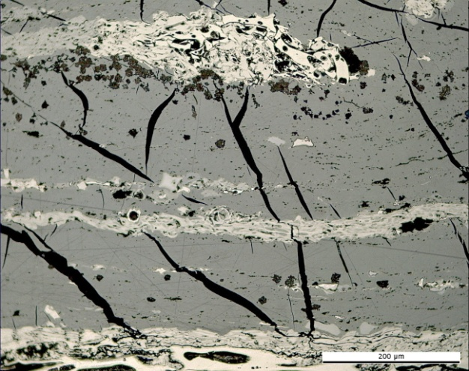 | 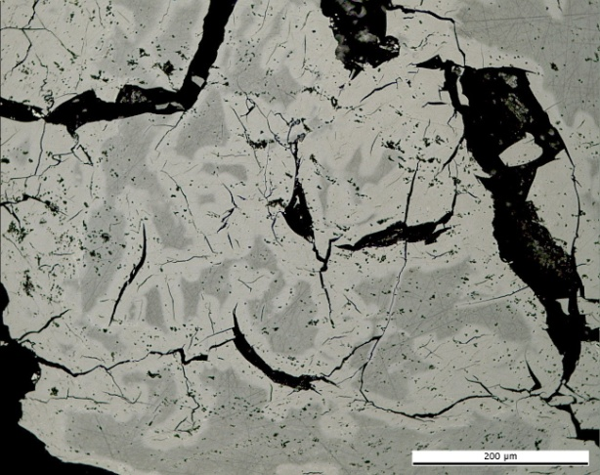
(c) | (d)
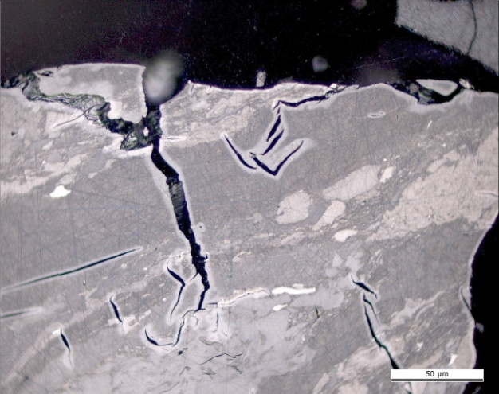 | 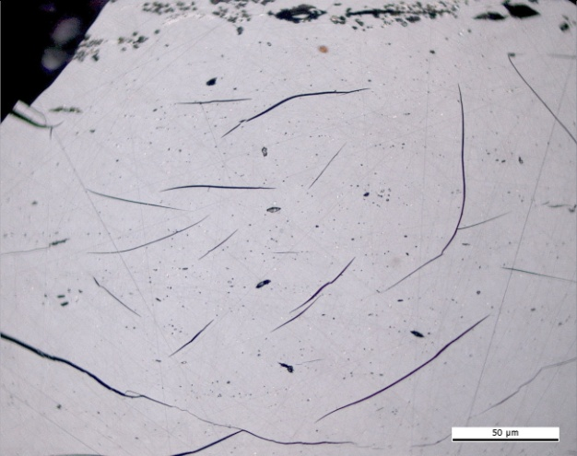
(e) | (f)
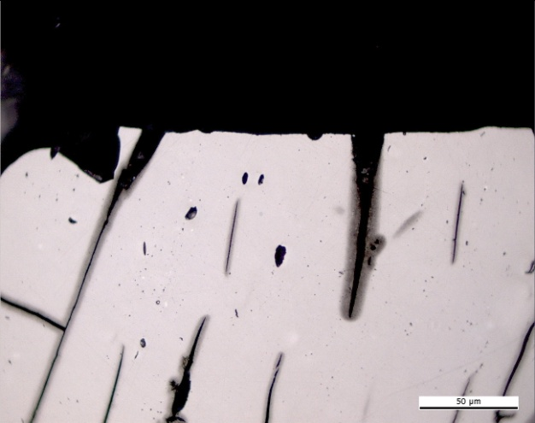 | 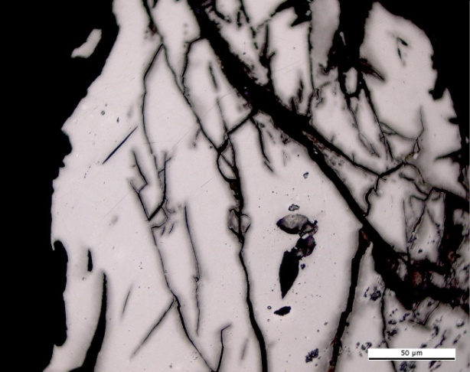
(g) | (h)

Plate 5. Photomicrographs showing the optical features of naturally in situ thermally oxidised coals in reflected light. Permian high volatile coal A. Wuda coal field, Inner Mongolia, China: (a),(d),(e) pale oxidation rims along microcracks, (b),(c),(f) shrinkage microcracks, (g),(h) dark oxidation rims and microcracks. Photomicrograph courtesy of J. Kus (MSc. DIC), Geochemistry of Petroleum and Coal Section, Energy Resources, Mineral Resources Department, Federal Institute for Geosciences and Natural Resources. Hannover, Germany.

