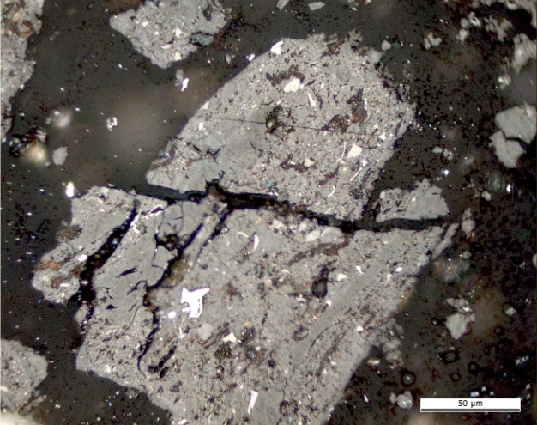 | 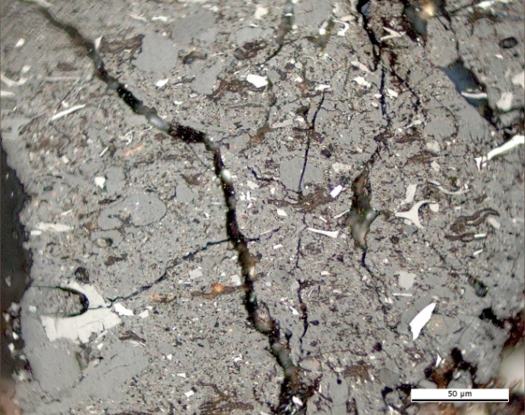
(a) | (b)
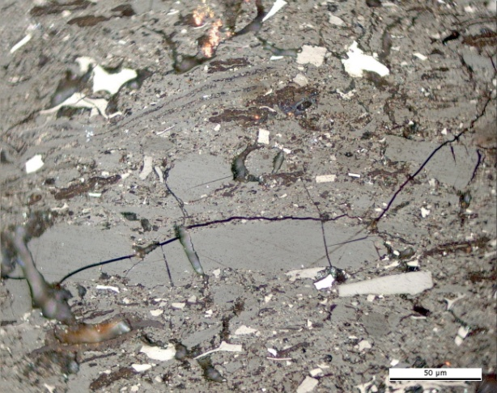 | 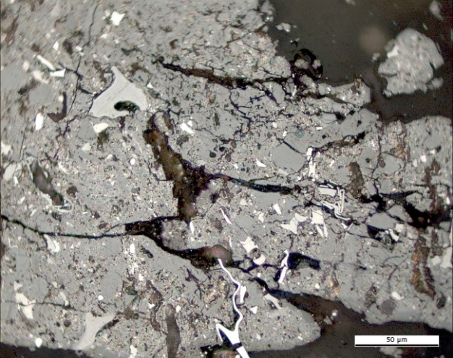
(c) | (d)
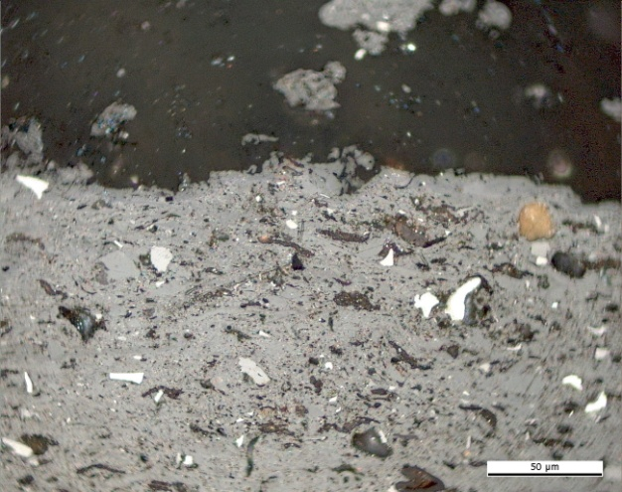 | 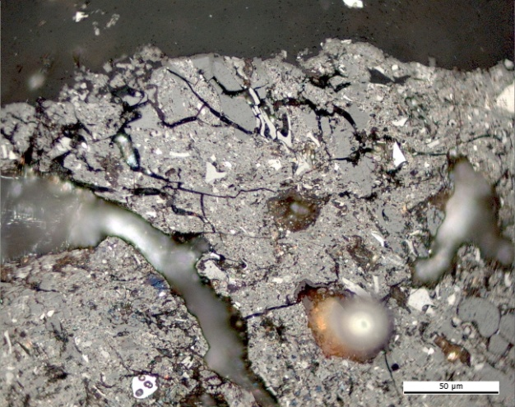
(e) | (f)

Plate 7. Photomicrographs showing the optical features of naturally in situ oxidised coals in Reflected light, oil immersion. Lower Cretaceous high volatile bituminous C coal. Mecklenburg-Vorpommern, Germany: (a),(b),(c),(d),(e),(f) microcracks and microfissures. Photomicrograph courtesy of J. Kus (MSc. DIC), Geochemistry of Petroleum and Coal Section, Energy Resources, Mineral Resources Department, Federal Institute for Geosciences and Natural Resources. Hannover, Germany.

