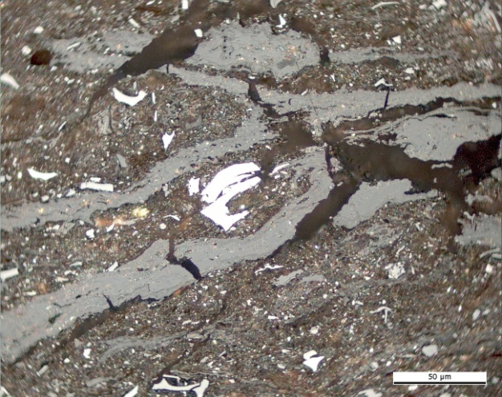 | 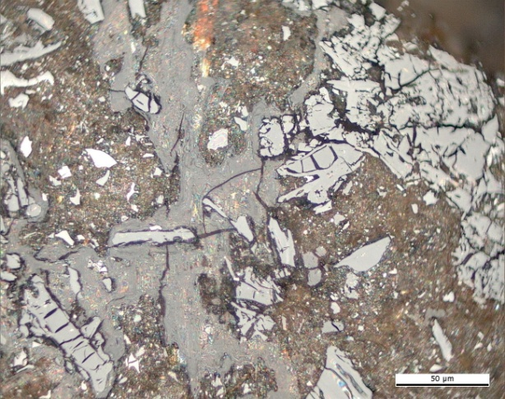
(a) | (b)
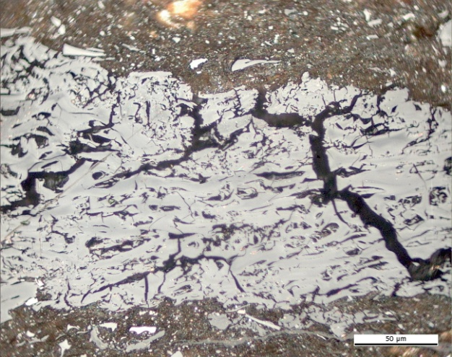 | 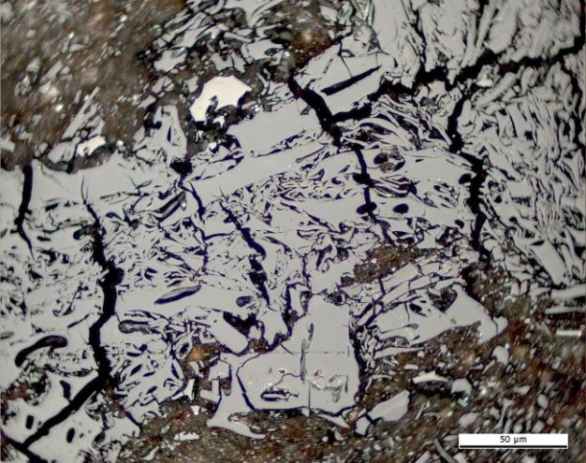
(c) | (d)
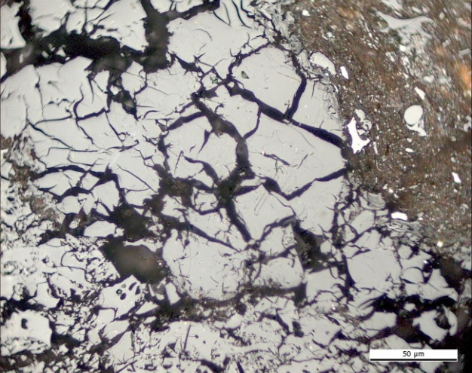
(e)

Plate 1. Photomicrographs showing the optical features of naturally in situ oxidised coals in Reflected light, oil immersion. Tertiary high volatile bituminous coal C. Aksa-Ata, western Tien-Shan Mountains, Usbekistan: (a) shrinkage cracks, (b),(c),(d),(e) microcracks and microfissures. Photomicrograph courtesy of J. Kus (MSc. DIC), Geochemistry of Petroleum and Coal Section, Energy Resources, Mineral Resources Department, Federal Institute for Geosciences and Natural Resources. Hannover, Germany.

