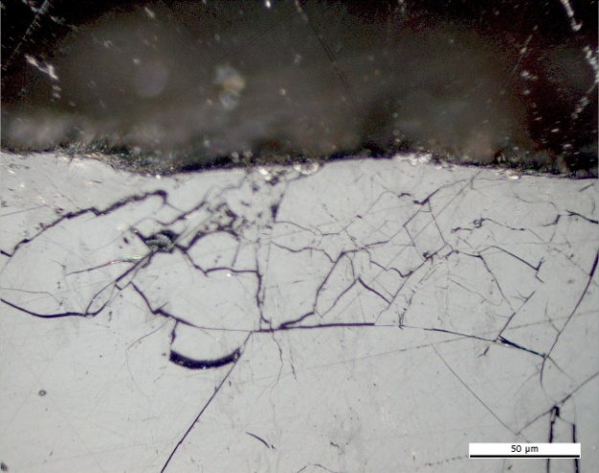 | 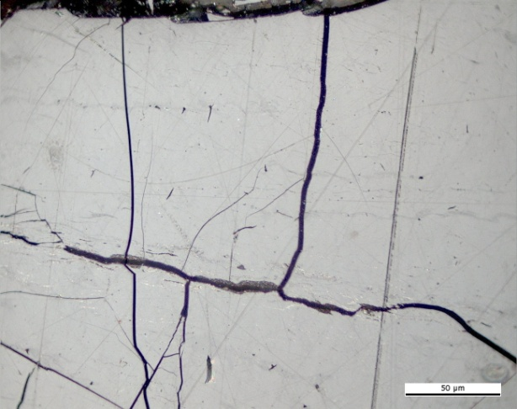
(a) | (b)
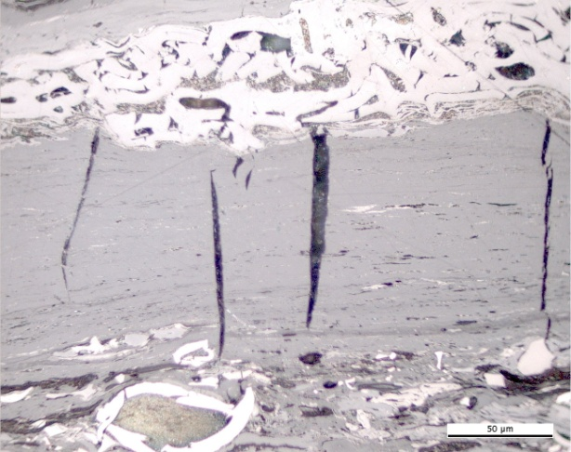 | 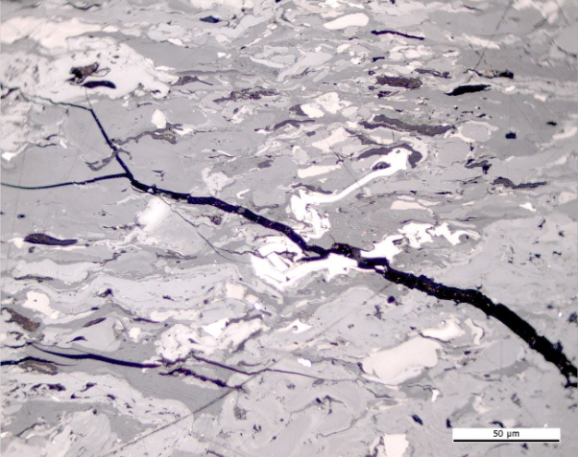
(c) | (d)
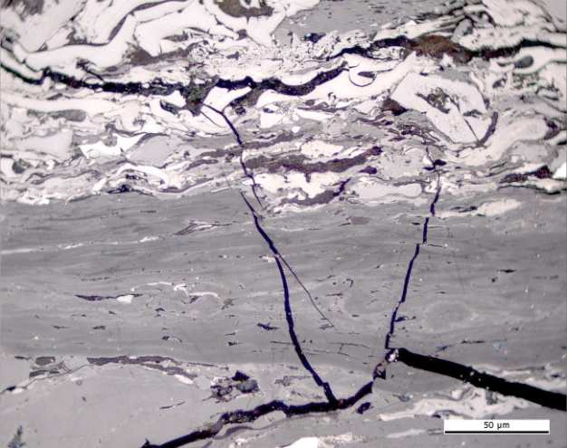 | 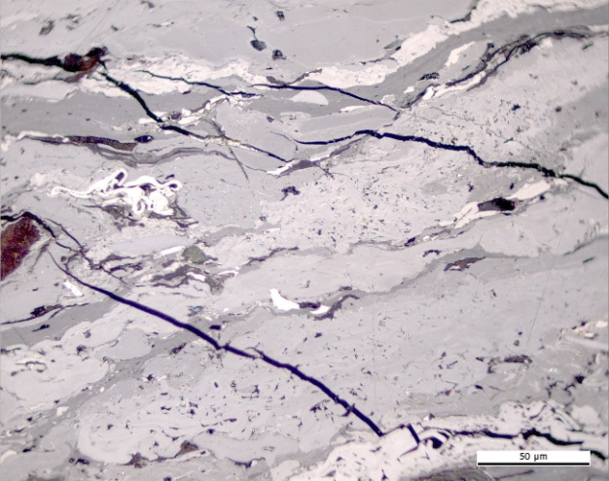
(e) | (f)

Plate 9. Photomicrographs showing the optical features of naturally in situ thermally oxidised coals in Reflected light, oil immersion. Permian high volatile bituminous A coal. Sakoa coal field. Madagascar: (a),(b),(d),(e),(f) microcracks and microfissures, (c) shrinkage microcracks. Photomicrograph courtesy of J. Kus (MSc. DIC), Geochemistry of Petroleum and Coal Section, Energy Resources, Mineral Resources Department, Federal Institute for Geosciences and Natural Resources. Hannover, Germany.

