ICCP

COMMISSION III

****

Self-heating of Coals and

Coal Wastes WG

2018 ROUND ROBIN REPORT

Convenors: **Dr. Jolanta Kus (Germany)**,

Dr. Magdalena Misz-Kennan (Poland),

Prof. Deolinda Flores (Portugal)

E-Mail: [J.Kus@bgr.de](mailto:J.Kus@bgr.de)

****

|  |  |
| --- | --- |
|  | LogoFCUP |

**Hannover, Germany, March 2020**

1. Introduction

The Self-heating Working Group was established during the 60th ICCP Meeting in Oviedo (Spain) in 2008. The respective information about the established working group was published in the ICCP News Letter No. 45, 2008. The aim of the Self-heating Working Group is:

* to gather examples of various forms of self-heating-related transformations of organic matter in coal and coal wastes of various ranks
* to create a classification of these self-heating induced transformations in coal and coal wastes.

Since 2008, several Round Robin Exercises on coal wastes were organized (in 2009, 2010, 2012, 2013, 2014, 2015, and 2016) and an attempt was made to classify transformation forms of oxidatively and thermally affected organic matter observed in coal disposal dumps. During the 2009 ICCP Meeting in Gramado/Porto Alegre, Brazil, it was decided that a separate classification should be prepared for oxidatively and thermally affected organic matter in coal wastes and for oxidatively and thermally affected coaly matter in coals that were subjected to self-heating processes. The classification of transformed organic matter in coal wastes was modified in a number of Round Robin Exercises owing to the great variety of form of organic particles present in coal wastes and is now published (Misz-Kennan et al., 2020).

Since 2018, the objectives of the SH WG is focused on the oxidatively and thermally affected organic matter observed in coal seams.

### 2. Objective of the 2018 SHWG Round Robin Exercise

The objective of the 2018 Round Robin Exercise was to:

1. to apply the established classification of oxidatively and thermally affected organic matter in coal wastes to oxidatively and thermally affected coaly matter in coals,
2. to test the applicability of the established classification of oxidatively and thermally altered organic matter in coal wastes to self-heated coals in coal seams in a ppt presentation.

During the 2018 Round Robin Exercise participants were asked to identify the selected oxidatively and thermally altered coaly particles in accordance to the established classification. Secondly, participants were asked to make comments on the identified forms and on the applied classification.

1. **Classification of thermally and oxidatively affected coaly matter in self-heated coals**

In the established classification of oxidatively and thermally coaly particles are divided into six levels:

|  |  |  |
| --- | --- | --- |
| **LEVEL 1** | **Description** | **Examples** |
| **LEVEL 1**  **All particles** | **COALY PARTICLES**  when composed of organic material | |  |  |  | | --- | --- | --- | |  |  |  | | 0703438-2 | 0703437-4 | 0703436-9 |   Oil immersion (n = 1.518) in reflected monochromatic non-polarized incident light, 50x |
| **MINERALS**  when made of minerals and/or various mineral phases | |  |  |  | | --- | --- | --- | | C:\KusJ\Hiltmann.W_ex_Koch\ERGEBNISBERICHTE\Sortiert nach Jahr\2005\2005 46884 2011 China JK\2. Ergebnisse\0510093\0510093_0012.jpg | **C:\KusJ\Hiltmann.W_ex_Koch\ERGEBNISBERICHTE\Sortiert nach Jahr\2005\2005 46884 2011 China JK\2. Ergebnisse\0510096\0510096_0011.jpg** | 0703434-2 | | 0703438-7 | 0703438-9 | 0703438-6 |   Oil immersion (n = 1.518) in reflected monochromatic non-polarized incident light, 50x |
| **LEVEL 2** | **Description** | **Examples** |
| **LEVEL 2**  **All particles**  **LEVEL 2**  **All particles**  **LEVEL 3**  **Non-altered** | **NON-ALTERED**  **PARTICLES**  Particles showing the same optical properties (reflectance, colour, fluorescence, morphology) as unaltered macerals; for further classification of non-altered particles see references: for huminite (Sýkorová et al., 2005), for vitrinite (ICCP, 1998), for liptinite (Pickel et al., 2017), for inertinite (ICCP, 2001). | |  |  |  | | --- | --- | --- | |  |  |  | |  |  |  |   Oil immersion (n = 1.518) in reflected monochromatic non-polarized incident light, 50x |
| **ALTERED**  **PARTICLES**  Particles with various signs of alteration such as: lower/higher reflectance, paler/darker colour, porosity connected with devolatilization, rounded edges, cracks, fissures etc. | |  |  |  | | --- | --- | --- | |  |  |  | |  |  |  |   Oil immersion (n = 1.518) in reflected monochromatic non-polarized incident light, 50x |
| **NEWLY FORMED**  **PARTICLES**  Particles that where formed as products of self-heating; | |  |  |  | | --- | --- | --- | |  |  |  | |  |  |  |   Oil immersion (n = 1.518) in reflected monochromatic non-polarized incident light, 50x |
| **VITRINITE**  **NON-ALTERED** | |  |  |  | | --- | --- | --- | |  |  |  |   Oil immersion (n = 1.518) in reflected monochromatic non-polarized incident light, 50x |
| **LIPTINITE**  **NON-ALTERED** | |  |  |  | | --- | --- | --- | |  |  |  |   Oil immersion (n = 1.518) in reflected monochromatic non-polarized incident light, 50x |
| **INERTINITE**  **NON-ALTERED** | |  |  |  | | --- | --- | --- | |  |  |  |   Oil immersion (n = 1.518) in reflected monochromatic non-polarized incident light, 50x |
| **LEVEL 3**  **Altered** | **MASSIVE**  **ALTERED**  Area without Devolatilisation Pores | |  |  |  | | --- | --- | --- | |  |  |  | |  |  |  |   Oil immersion (n = 1.518) in reflected monochromatic non-polarized incident light, 50x |
| **POROUS**  **ALTERED**  Devolatilisation Pores | |  |  |  | | --- | --- | --- | |  |  |  | |  |  |  |   oil immersion (n = 1.518) in reflected monochromatic non-polarized incident light, 50x |
| **LEVEL 3**  **Newly formed**  **LEVEL 3**  **Newly formed**  **LEVEL 3**  **Newly formed** | **BITUMEN**  **NEWLY FORMED**  Expulsions of hydrocarbons generated during self-heating processes largely from liptinite macerals; they have various shape: droplets, thread-like structures or are of irregular nature; commonly they co-occur with minerals and have strong yellowish fluorescence; for further reference see Alpern et al. (1992). | |  |  |  | | --- | --- | --- | |  |  |  | |  |  |  |   Oil immersion (n = 1.518) in reflected monochromatic non-polarized incident light, 50x |
| **PYROLYTIC CARBON**  **NEWLY FORMED**  Strongly anisotropic organic matter occurring in the form of ribbons, thin laminae; it occurs separately, on the edges of forms or within strongly thermally altered particles; for further references see Taylor et al. (1998). | |  |  |  | | --- | --- | --- | |  |  |  |   Oil immersion (n = 1.518) in reflected monochromatic non-polarized incident light, 50x |
| **CHARS**  **NEWLY FORMED**  Organic particles with pyrolysis char morphology characterised  by randomly distributed pores and varying porosity, shape, and size; their colour in reflected white light is light grey to white, and the reflectance is always higher than the prime huminite/vitrinite; Kwiecińska  and Petersen (2004). | |  |  |  | | --- | --- | --- | |  |  |  | |  |  |  |   Oil immersion (n = 1.518) in reflected monochromatic non-polarized incident light, 50x |
| **COKES**  **NEWLY FORMED**  Coal heated in the absence of air, vesiculated and harden into coke. For further reference on similar textures and structures in metallurgical coke see Suárez-Ruiz and Crelling (2008), on natural coke Kwiecińska and Petersen (2004). | |  |  |  | | --- | --- | --- | |  |  |  | |  |  |  |   Oil immersion (n = 1.518) in reflected monochromatic non-polarized incident light, 50x |
| **MICRINITE**  **NEWLY FORMED**  Rapid heating of liptinite during the self-heating process can lead to formation of micrinite. The newly formed micrinite mimics the shape, outline of former (unaltered) cutinite, sporinite and other liptinite macerals. It occurs as fine-grained material characterized by a high reflectance. | |  |  |  | | --- | --- | --- | |  |  |  |   Oil immersion (n = 1.518) in reflected monochromatic non-polarized incident light, 50x |
| **LEVEL 4**  **Altered** | **NON-FLUORESCENT**  **ALTERED**  Coal grains lacking fluorescence. | |  |  |  | | --- | --- | --- | |  |  |  | |  |  |  |   Oil immersion (n = 1.518) in reflected monochromatic non-polarized incident light, 50x |
| **FLUORESCENT**  **ALTERED**  Coal grains displaying fluorescence. | |  |  |  | | --- | --- | --- | |  |  |  | |  |  |  |   Oil immersion (n = 1.518) in reflected monochromatic non-polarized incident light, 50x |
| **LEVEL 5**  **Altered** | **ISOTROPIC**  **ALTERED**  **C**oal grains with lack of optical anisotropy in polarised light. | |  |  |  | | --- | --- | --- | |  |  |  | |  |  |  |   Oil immersion (n = 1.518) in reflected monochromatic **non-**polarized and polarized incident light, 50x, respectively |
| **NON – ISOTROPIC**  **ALTERED**  Coal grains with optical anisotropy in polarised light. | |  |  |  | | --- | --- | --- | |  |  |  | |  |  |  |   oil immersion (n = 1.518) in reflected monochromatic **non-**polarized and polarized incident light, 50x, respectively |
| **LEVEL 6**  **Non-altered,**  **Altered,**  **Newly**  **formed**  **LEVEL 6**  **Non-altered,**  **Altered,**  **Newly**  **formed**  **LEVEL 6**  **Non-altered,**  **Altered,**  **Newly**  **formed** | **FRACTURES, FISSURES ALTERED**  Irregular cracks occurring at the edges of coal grains or within coaly particles. | |  |  |  | | --- | --- | --- | |  |  |  | |  |  |  |   Oil immersion (n = 1.518) in reflected monochromatic non-polarized incident light, 50x |
| **PALER IN COLOUR OXIDATION RIMS**  Paler in colour rims of higher reflectance occurring along the edge of particles, at fractures, fissures or around devolatilisation pores. | |  |  |  | | --- | --- | --- | |  |  |  | |  |  |  |   Oil immersion (n = 1.518) in reflected monochromatic non-polarized incident light, 50x |
| **DARKER IN COLOUR OXIDATION RIMS**  Darker in colour rims of higher reflectance occurring along the edge of particles, at fractures, fissures or around devolatilisation pores. | |  |  |  | | --- | --- | --- | |  |  |  | |  |  |  |   Oil immersion (n = 1.518) in reflected monochromatic non-polarized  incident light, 50x |
| **PLASTICISED EDGES**  Particles with plasticised external edge. | |  |  |  | | --- | --- | --- | |  |  |  | |  |  |  |   Oil immersion (n = 1.518) in reflected monochromatic non-polarized incident light, 50x |
| **DEVOLATILISATION PORES** Particles with pores that are usually round or oval in shape, sometimes they are elongated; their size is from a few to tens of µm; only pores related to thermal processes are included; porosity being an original feature of maceral, e.g. porosity of fusinite, is not included here. | |  |  |  | | --- | --- | --- | |  |  |  | |  |  |  |   Oil immersion (n = 1.518) in reflected monochromatic non-polarized incident light, 50x |
| **PALER IN COLOUR PARTICLE** Vitrinite grains of higher reflectance compared with the background value. | |  |  |  | | --- | --- | --- | |  |  |  | |  |  |  |   oil immersion (n = 1.518) in reflected monochromatic non-polarized incident light, 50x |

In the **Level 3 “Newly** **Formed” – Bitumen, Pyrolytic Carbon, Chars, Cokes, and Micrinite** the option Graphite has been removed as graphite has not been observed in coals subjected to self-heating processes. In addition, the category of Micrinite has been introduced for the first time. The category micrinite in self-heated coals mimics the shape and outline of former (unaltered) liptinite macerals such as e.g., cutinite and sporinite are formed as a result of rapid thermal alteration in self-heated coals. It is characterised by a granular appearance and high reflectance.

1. **Classification of thermally and oxidatively altered coaly matter in self-heated coals**

The following classification of thermally and oxidatively altered coaly matter in coal has been adapted from the classification of thermally and oxidatively altered coaly matter in coal wastes published by Misz-Kennan et al. (2020) (Fig. 1). In the Level 3 the category “graphite” has been replaced by the category “micrinite” and in the Level 6 the category “bands” has been removed.

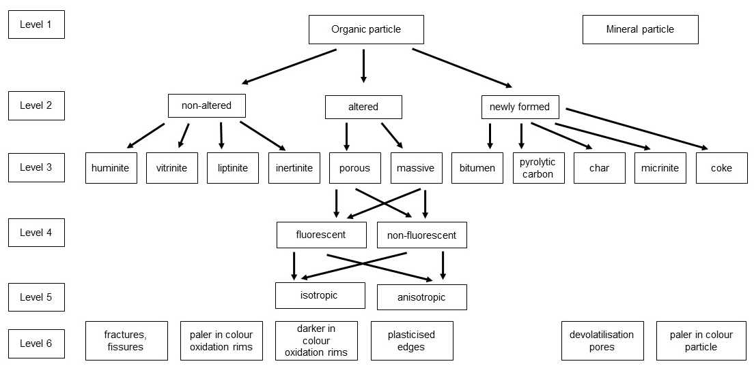

Fig. 1. Classification of thermally and oxidatively altered coaly matter in self-heated coals adopted from classification of thermally and oxidatively altered coaly matter in coal wastes (modified after Misz-Kennan et al., 2020).

1. **Round Robin Exercise**

The 2018 Round Robin Exercise was based on 62 photos representing 60 particles that were prepared from self-heated high volatile bituminous coals. The background mean random vitrinite reflectance was 0.94% VRr with standard deviation of 0.04. The vitrinite reflectance values below 0.90% VRr and above 0.98 VRr were considered to be oxidatively and thermally altered coals.

Participants were asked to:

1. Determine the form of coaly matter in the rectangle in accordance to the established classification (see chapter 2) and mark the answer in the attached Excel file (2018 Round Robin Exercise SHWG.xls).

How to mark answers:

1. In case of **Level 1: unaltered particles**, please mark **one** of three columns: vitrinite or liptinite or inertinite.
2. In case of **Level 2: non-altered, altered and newly formed particles**, please mark **one** of them.
3. In case of **level 3:** **non-altered – vitrinite, inertinite, liptinite**, please mark **one** of them.
4. In case of **level 3:** **altered – altered vitrinite, altered inertinite, altered liptinite**, please mark **one** of them.
5. In case of **level 3:** **newly formed – bitumen, pyrolytic carbon, chars, graphite, coke, micrinite**, please mark **one** of them.
6. In case of **level 4:** **altered – fluorescent and non-fluorescent**, please mark **one** of them.
7. In case of **level 5:** **altered – isotropic and non-isotropic**, please mark **one** of them.
8. In case of **level 6:** **newly formed –fractures, fissures; paler in colour oxidation rims; darker in colour oxidation rims; plasticised edges; bands; devolatilisation pores; paler in colour particle**,please make **multiple answers**, if adequate.

### Results of the 2018 Round Robin Exercise

The 2018 Round Robin Exercise involved participation of 12 parties, mainly from academia with Ali İhsan Karayiğit, Claudio Avila, Deolinda Flores, Georgeta Predeanu, Ivana Sýkorová, Joana Ribeiro, Kimon Christanis, Nikki Wagner, Sławka Pusz, Stavros Kalaitzidis, Walter Pickel, and Zeynep Buckun. The aspects, which are discussed in the sub-sequent chapters, are pointed out.

5.1 Particles identified in Level 2 as either “Non-Altered” or “Altered”

Particles with mean random vitrinite reflectance equal to background value of 0.94% VRr and within the SD of 0.04 were identified in Level 2 as either Non-Altered or Altered category (Fig. 2). According to the exercise guidelines, where mean random vitrinite reflectance was taken as a primary indicator for self-heating processes, such particles should be considered as Non-Altered category.

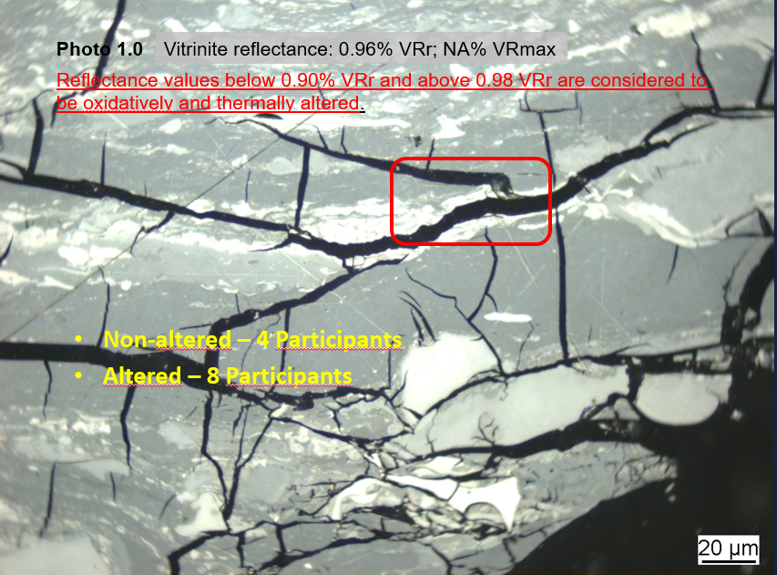

Fig. 2. Coal with mean random vitrinite reflectance of 0.96% and within the SD of 0.04 is characterized by fractures, and fissures. Coal particles under the red rectangle were identified in Level 2 as either “Non-Altered” or “Altered”.

Suggestion: It is suggested for the 2020 Round Robin Exercise to introduce a modified definition of the item Non-Altered category. The Non-Altered category may also describe particles with vitrinite reflectance equal to background value of 0.94% VRr and within the SD of 0.04 and lacking any shrinkage fractures and fissures. Also the term Altered is suggested to be modified and as such it will describe particles with vitrinite reflectance equal to background value of 0.94% VRr and within the SD of 0.04 and displaying shrinkage fractures and fissures. Based on the evaluation of results of the 2018 round robin exercise, shrinkage fractures and fissures are a prominent sign of oxidative alteration in coals subjected to self-heating and self-combustion processes.

5.2 Particles identified in Level 2 as either Altered or Newly Formed

Particles with mean vitrinite reflectance higher than background value of 0.94% VRr and within SD higher than 0.04 and characterized by occurrences of micrinite were identified in Level 2 either as Newly Formed or as Altered category (Fig. 3). According to the exercise guidelines, the status for such particles should be classified in the Newly Formed category.

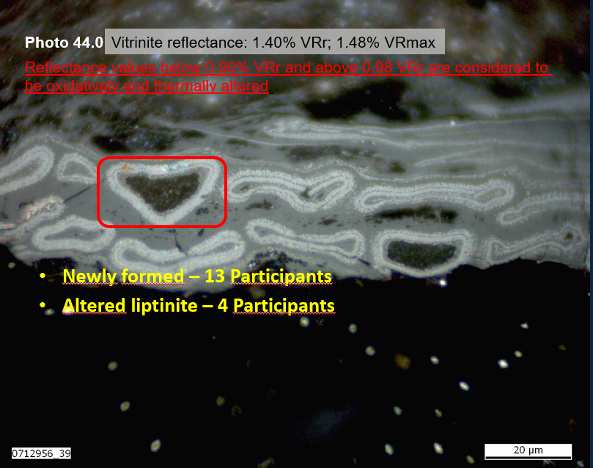

Fig. 3. Coal with mean random vitrinite reflectance of 1.40% is characterized by occurrence of micrinite. Coal particles under the red rectangle were identified in Level 2 either as “Newly-formed” or as “Altered”.

Suggestion: It is suggested for the 2020 SHWG Round Robin Exercise to characterize micrinite, displaying the form of former liptinite macerals as a Newly Formed category.

5.3 Particles identified in Level 3 as either Micrinite or Coke

Particles with mean vitrinite reflectance higher than background value of 0.94% VRr and higher SD higher than 0.04 and classified as Micrinite and Cokes categories were largely misidentified (Fig. 4). According to the exercise guidelines, micrinite can maintain the shape (outline) of former unaltered liptinite macerals. It occurs as fine-grained material characterized by a higher reflectance. On the other hand, coke is coal heated in the absence of air, vesiculated and harden. For further reference on similar textures and structures in metallurgical coke, see Suárez-Ruiz and Crelling (2008), on natural coke Kwiecińska and Petersen (2004).

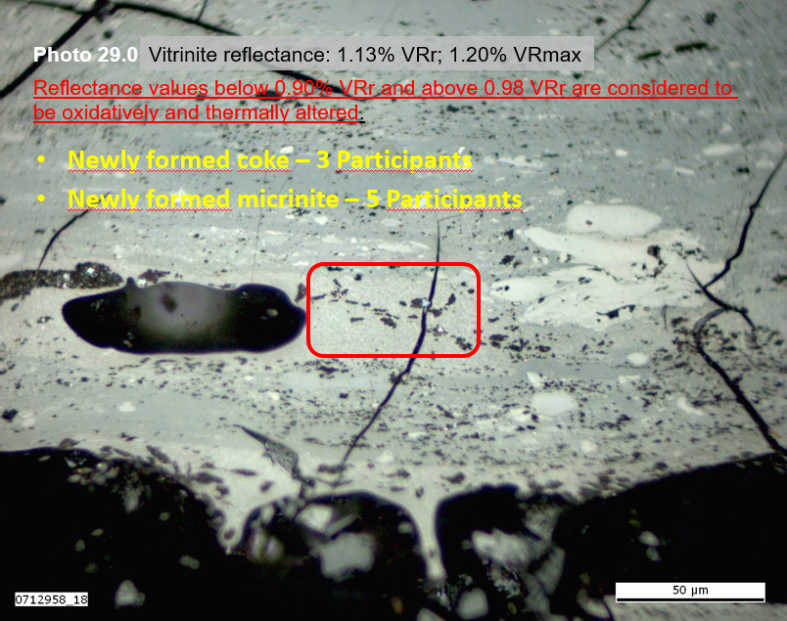

Fig. 4. Coal with mean random vitrinite reflectance of 1.13% is characterized by occurrence of coke. Coal particle under the red rectangle was identified in Level 3 either as “Micrinite” or as “Coke”.

Suggestion: It is suggested for the 2020 SHWG Round Robin Exercise to modify the description of Coke category and provide more graphical examples for the Coke and Micrinite categories at a better lateral resolution.

5.4 Particles identified in Level 6 as either Paler in colour particles

Particles with mean vitrinite reflectance higher than background value of 0.94% VRr and SD higher than 0.04 as well as classified as Paler in Color Particles were largely misidentified (Fig. 5).

According to the exercise guidelines, paler in colour particles are vitrinite grains of higher reflectance compared with the background value of an unaltered vitrinite. In addition, paler in colour particle does not refer to the paler in colour oxidation rim. A possible reason for the low number of identified paler in colour particles is the lack of reference colour of a background-unaltered vitrinite.

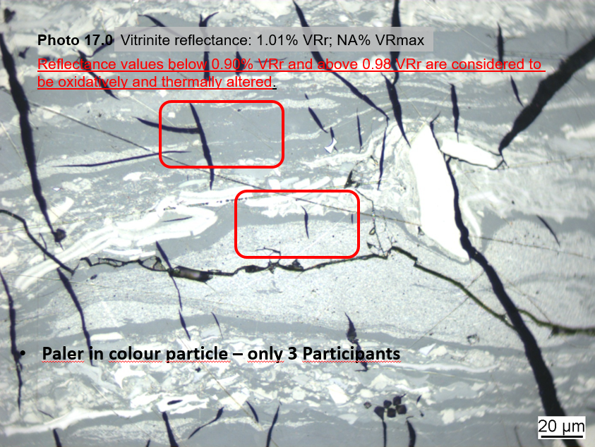

Fig. 5. Coal with mean random vitrinite reflectance of 1.01% is characterized by occurrence of pale in color particles. Coal particles under the red rectangle were scarcely identified as “Pale in color particle”.

Suggestion: For the 2020 SHWG Round Robin Exercise it is suggested to: (1) insert a box on each photomicrograph with the actual background colour of vitrinite for an unequivocal comparison and (2) to state that the option “Paler in colour particle” against the former definition can also refer to the paler in colour oxidation rim at vitrinite grain.

5.4 Evaluation of results

The evaluation of results obtained in the 2018 Round Robin Exercise followed three different evaluation schemes, which are as follows:

1. **Raw Agreement Indices** with only the Overall Level of Agreement being evaluated for each of the categories in this report.
2. **Standard Statistical Evaluation** with the minimum, maximal, and average level of agreement values being evaluated.
3. **Detailed Statistical Evaluation**
   * 1. **Raw Agreement Indices**

The raw agreement indices were applied to categories identified by participants and as established by Uebersax (2001) and used by Predenau et al. (2015). The evaluated index for the obtained results is the overall level of agreement (LOA). LOA considers both the correct identified answers (positive identification) as well as lack of response, but identified and not marked (negative identification), as well as incorrect responses (disagreement). The LOA gives a broader information of the evaluation status and is more accurate. The equation used is given as:

Po=a+d/a+b+c+d=a+d/N

where:

a is the number of positive agreement;

d is the number of negative agreement;

b and c are the numbers of disagreement

The results obtained by each of the participants point towards in general to a generally satisfactory outcome.

**Non-Altered Particles**

The LOA for the category Non-Altered Particles as displayed in Fig. 6 and as identified by each of participants reveals well-comparable results among the participants. The LOA ranges between 83% and 100% and its average amounts to **97.5%**.



Fig. 6. Level of overall agreement for the category Non-Altered Particles obtained by the participants in the 2018 Round Robin Exercise.

**Altered Particles**

The next category Altered Particles represents a slightly lower outcome of each of the 12 participants with a range between 70% and 95% and the average LOA of **82.8%** (Fig. 7).



Fig. 7. Level of overall agreement for the category Altered Particles obtained by the participants in the 2018 Round Robin Exercise.

**Newly Formed Particles**

A better scenario of LOA is shown for the Newly Formed Particles category when compared to the category Altered Particles with a range between 82% and 100% and the average LOA of **90.7%** (Fig. 8).



Fig. 8. Level of overall agreement for the category Newly Formed Particles obtained by the participants in the 2018 Round Robin Exercise.

**Vitrinite Non-Altered**

The LOA for the category Vitrinite Non-Altered as displayed in Fig. 9 displays well-comparable results among the 12 participants with an average of LOA of **98.6%**.



Fig. 9. Level of overall agreement for the category Vitrinite Non-Altered obtained by the participants in the 2018 Round Robin Exercise.

**Altered vitrinite**

A still satisfactory, although markedly lower LOA is shown for the category Altered Vitrinite with a range between 68% and 97% and the average LOA of **80.9%** (Fig. 10).



Fig. 10. Level of overall agreement for the category Altered Vitrinite obtained by the participants in the 2018 Round Robin Exercise.

**Coke**

A well-comparable outcome among the participants was obtained for the category Coke is displayed in Fig. 11 with the average LOA of **91.4%**.



Fig. 11. Level of overall agreement for the category Coke obtained by the participants in the 2018 Round Robin Exercise.

**Fractures, Fissures Altered**

Again, a still satisfactory level of LOA, although of much lower average value is shown by the category Fractures, Fissures, Altered with the lowest average level of LOA of **78.7%** (Fig. 12).



Fig. 12. Level of overall agreement for the category Fractures, Fissures Altered obtained by the participants in the 2018 Round Robin Exercise.

**Paler in Colour Particle Altered**

The most inhomogeneous distribution of LOA among the participants with the lowest average of LOA of 75.8% is displayed for the category Paler in Colour Particle in Fig. 13. This category generated the most difficulties in identification of the thermally altered coals.

****

Fig. 13. Level of overall agreement for the category Paler in Colour Particle obtained by the participants in the 2018 Round Robin Exercise.

**5.4.2 Standard Statistical Evaluation**

Standard statistical evaluation of the obtained results follows a different approach, namely a comparison of minimum, maximum, and average level of agreement (in %) obtained by all participants for categories evaluated in images (Fig. 14).

For the most categories, the average level of agreement amounts to values above 90% as marked by the blue colour. Even though, the average level of agreements is high, for some categories in the Level 6 the spread of values is relatively high. This can be explained by the fact, that identification in minor cases requires possibly more support in terms of modification of definitions and supply of more meaningful microscope images.

For the following categories marked in yellow: Non-altered, Non-altered vitrinite, and Altered Liptinite the average level of agreement ranges between **80%** and **90%**. Only three categories: Non-Altered, Altered-Vitrinite, and Paler in Colour Particles posed distinct difficulties with the average level of agreement ranging between about **62.8%** for Altered Vitrinite and **72.6%** for Altered Particles. These categories display also a relatively high dispersion of data sets. The categories Non-fluorescent, Fluorescent, Isotropic and Non-Isotropic were not evaluated in this 2018 round.



Fig. 14. Minimum, maximum, and average level of agreement (in %) obtained for individual morphological forms of organic matter in thermally and oxidatively altered coals by participants of 2018 Round Robin Exercise.

**5.4.3 Detailed Statistical Evaluation**

Ewa Szram, a colleague of Magdalena Misz-Kennan from the Department of Natural Sciences at the Silesia University in Sosnowiec, Poland applied a scheme of a detailed statistical evaluation to the results obtained by participants for the categories and forms in images.

The following statistics refers to evaluation of data with respect to the **categories ranging from Coaly Particle to Paler in Colour Particle**. Detailed statistical evaluation embraces the so-called Grubb’s test and the box-and-whisker diagram and were applied to check for outliers and extreme values and to identify these deviations in the data sets.

The **Grubb’s test** checks for outliers by comparing maximum values of the absolute differences between the values and their mean. It evaluates the presence of outliers in a univariate data set, assuming the data are described to have a normal distributed population. Thus, the results indicate a probability that the evaluated data belongs to the core population. The applied level of significance was set to **0.05** for number of slides or forms that were identified: **n=60**. In Tab. 1 results of the Grubb’s test are displayed. Based on the applied level of significance and number of identified forms the critical value is equal to **3.03**. Values, which are lower than **3.03** indicate lack of outliers and are highlighted in Tab.1. These include among others Non-altered category or Altered Vitrinite. The remaining values suggest the presence of deviance and statistical irregularities.

Table 1. Results of the Grubb’s test applied to categories.

|  |  |  |  |  |  |  |  |  |  |  |  |  |  |  |  |  |  |  |  |  |  |  |  |  |
| --- | --- | --- | --- | --- | --- | --- | --- | --- | --- | --- | --- | --- | --- | --- | --- | --- | --- | --- | --- | --- | --- | --- | --- | --- |
| Coaly Particle | Minerals | Non-Altered | Altered | Newly Formed Particle | Non-Atered Huminite | Non-Altered Vitrinite | Non-Altered Liptinite | Non-Altered Inertinite | Altered Huminite | Altered Vitrinite | Altered Liptinite | Altered Inertinite | Bitumen | Pyrolytic carbon | Chars | Coke | Micrinite | Fractures, Fissures Altered | Paler in colour oxidation rims | Darker in colour oxidation rims | Plasticised edges | Bands | Devolatilisation pores | Paler in Colour Particles |
| 5.010279 | 5.008184 | **2.179843** | **1.995729** | 3.447476 | 7.616867 | **2.245122** | 4.322422 | 4.380737 | - | **1.811084** | **2.330729** | 6.974674 | 5.060456 | 3.710346 | 3.409119 | **2.914792** | 3.918251 | 3.475257 | 6.220975 | 4.009841 | 3.567909 | **2.388331** | 4.947146 | **1.813886** |

In the **box-and-whisker diagram**, the lower and upper limits are used as diagnostic tools to identify observations that might be outliers and extreme values. Observations, which lie below or above these limits, are termed outliers and extreme values. For the same categories as displayed in Tab. 1, box-and-whisker diagram in Fig. 15 shows a markedly higher numbers of outliers and extreme values. This might be caused by the fact that majority of the evaluated categories follows a non-normal distribution as confirmed by the outcome of the **Kolmogorov-Smirnov, Lilliefors, and Shapiro-Wilk tests at a level of confidence of 0.05. The only exemption are the following categories: Altered, Altered Vitrinite, and Paler in Colour Particle. The presence of the outliers and extreme values can significantly alter or misrepresent statistical results.** The box-and-whisker diagram for the identified categories supplies also other statistical information. Sample size of data evaluated for each of the identified categories in Fig. 15 does not affect the appearance of the diagram as the population, i.e., the sample size is more than 20.

With regard to the skewness, only the data in category Altered is right-skewed, indicating that data may not be normally distributed and that the mean is greater than the median. The range between the highest and the lowest value shows the highest degree of dispersion (spread). It gives an idea of how much variation is observed in the displayed categories. The highest range is observed in the following categories: Non-Altered, Altered, Non-Altered Vitrinite, Altered Vitrinite, Altered Liptinite, Paler in Colour Oxidation Rim, and Paler in Colour Particles.

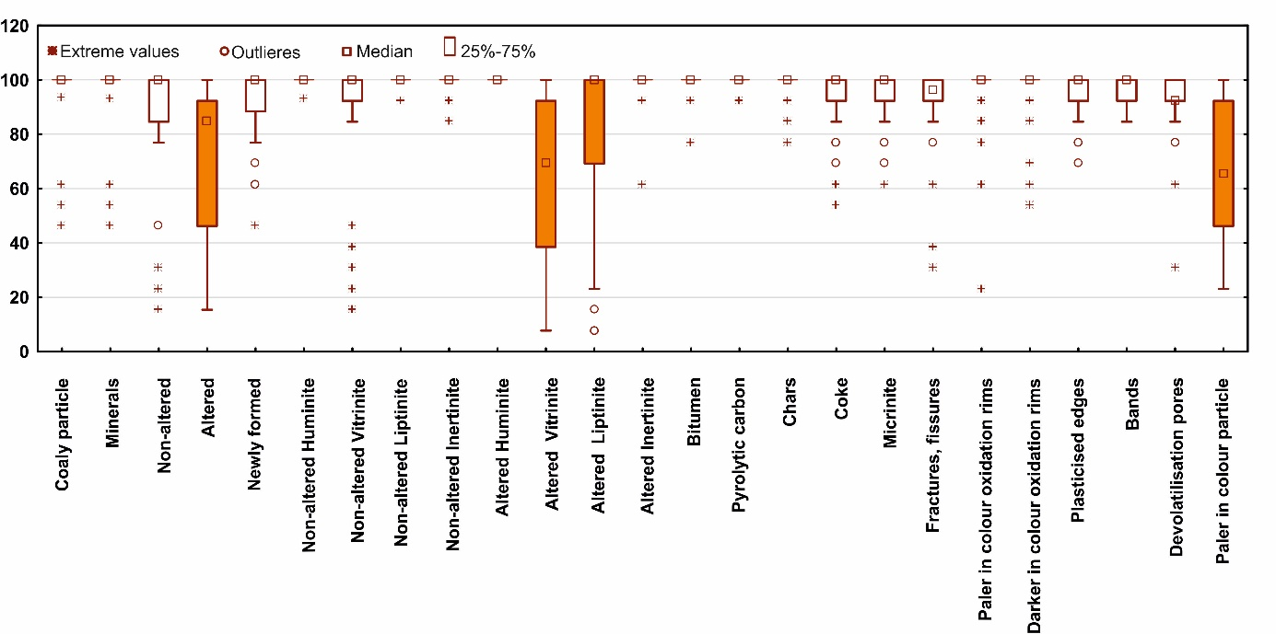

Fig. 15. The box-and-whisker diagram with extreme values, outliers, median and non-outlier range (25%-75%), obtained for 25 categories (Coaly particle to Paler in colour particle) in thermally and oxidatively altered coals in the 2018 Round Robin Exercise.

As the range takes the count of extreme values only, it sometimes might not reflect an adequate degree of variability. The Interquartile range (IQR) is a more representative measure of data spread as it not affected by outliers and extreme values. The highest IQR is noted for the categories Altered Vitrinite, Altered Liptinite, Altered and Paler in Colour Particle.

**Based on the** box-and-whisker diagram of the identified categories grouped into Levels 1 to 6, the highest range is observed in the Level 4 with the highest IQR documented likewise for the Level 4 (Fig. 16).

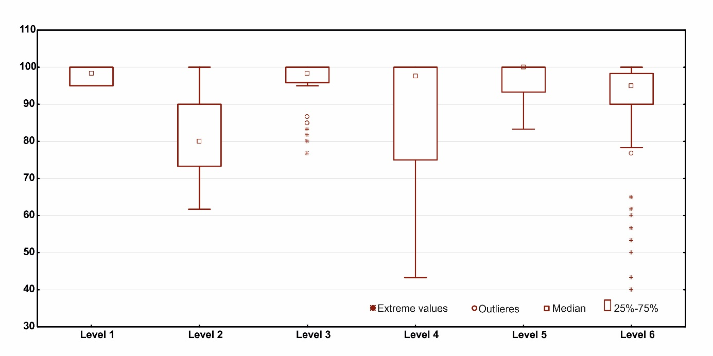

Fig. 16. The box-and-whisker diagram with extreme values, outliers, median and non-outlier range (25%-75%), obtained for categories and grouped into levels (1 to 6) in thermally and oxidatively altered coals in the 2018 Round Robin Exercise.

**Conclusion drawn from the evaluation with respect to categories:**

* The category Altered Vitrinite was the least recognisable class.
* Based on the arithmetic mean, the category Coaly Particle was better identified in the Level 1 than Minerals, although the **numerical account of mode for category Minerals was higher. The variation of coefficient was lower for category Coaly Particle.**
* The category Newly formed in the Level 2 was best identified as opposed to category Altered.
* The category Bitumen in the Level 3 was best identified as opposed to category Coke.
* The category Darker in colour oxidation rims in the Level 6 was best identified as opposed to category Paler in Colour Particle.

The following data statics refers to evaluation of forms as identified in each of the photomicrographs.

The results of the Grubb’s test shown in Tab. 2 reveal the level of significance of 2.56 and number of identified categories being equal to 25. Values, which are lower than 2.56 indicate lack of outliers and extreme values and include the following photomicrographs: 1, 2, 3, 6, 7, 11, 12, 12, 14, 16, 20, 23, 24, 26, 29, 30, 31, 32, 48, 55, and 56.

Table 2. Results of the Grubb’s test applied to photomicrographs. Numbers from 1 to 60 define the order of photomicrographs that were identified.

|  |  |  |  |  |  |  |  |  |  |  |  |  |  |  |  |  |  |  |  |  |  |  |  |  |
| --- | --- | --- | --- | --- | --- | --- | --- | --- | --- | --- | --- | --- | --- | --- | --- | --- | --- | --- | --- | --- | --- | --- | --- | --- |
| 1 | 2 | 3 | 4 | 5 | 6 | 7 | 8 | 9 | 10 | 11 | 12 | 13 | 14 | 15 | 16 | 17 | 18 | 19 | 20 | 21 | 22 | 23 | 24 | 25 |
| **2.500922** | **2.310557** | **2.238416** | 3.175760 | 2.884155 | **2.413156** | **2.209351** | 3.400000 | 3.760077 | 3.366405 | **2.130173** | **2.165909** | **2.149425** | **2.363649** | 3.002221 | **2.231665** | 4.214216 | 2.992208 | 4.459561 | **2.468772** | 2.763546 | 3.153058 | **2.111539** | **2.290074** | 2.764927 |
| 26 | 27 | 28 | 29 | 30 | 31 | 32 | 33 | 34 | 35 | 36 | 37 | 38 | 39 | 40 | 41 | 42 | 43 | 44 | 45 | 46 | 47 | 48 | 49 | 50 |
| **2.116763** | 2.712855 | 2.971573 | **2.498567** | **2.301904** | **2.232795** | **2.202391** | 4.098947 | 4.574932 | 4.623209 | 4.337741 | 3.696739 | 2.883592 | 3.784462 | 2.844755 | 3.615076 | 3.288925 | 3.002530 | 3.037042 | 3.649835 | 3.208968 | 4.009487 | **2.048664** | 3.971771 | 3.163620 |
| 51 | 52 | 53 | 54 | 55 | 56 | 57 | 58 | 59 | 60 |  |  |  |  |  |  |  |  |  |  |  |  |  |  |  |
| 3.929029 | 2.925853 | 3.202291 | 3.330402 | **2.376718** | **2.304096** | 3.063467 | 2.706388 | 3.345980 | 3.345980 |  |  |  |  |  |  |  |  |  |  |  |  |  |  |  |

For the same photomicrographs as displayed in Tab. 2, box-and-whisker diagram in Fig. 17 shows a markedly higher numbers of outliers and extreme values. This might be caused by the fact that all of the evaluated categories follows a non-normal distribution as confirmed by the outcome of the **Kolmogorov-Smirnov, Lilliefors, and Shapiro-Wilk tests at a level of confidence of 0.05.**

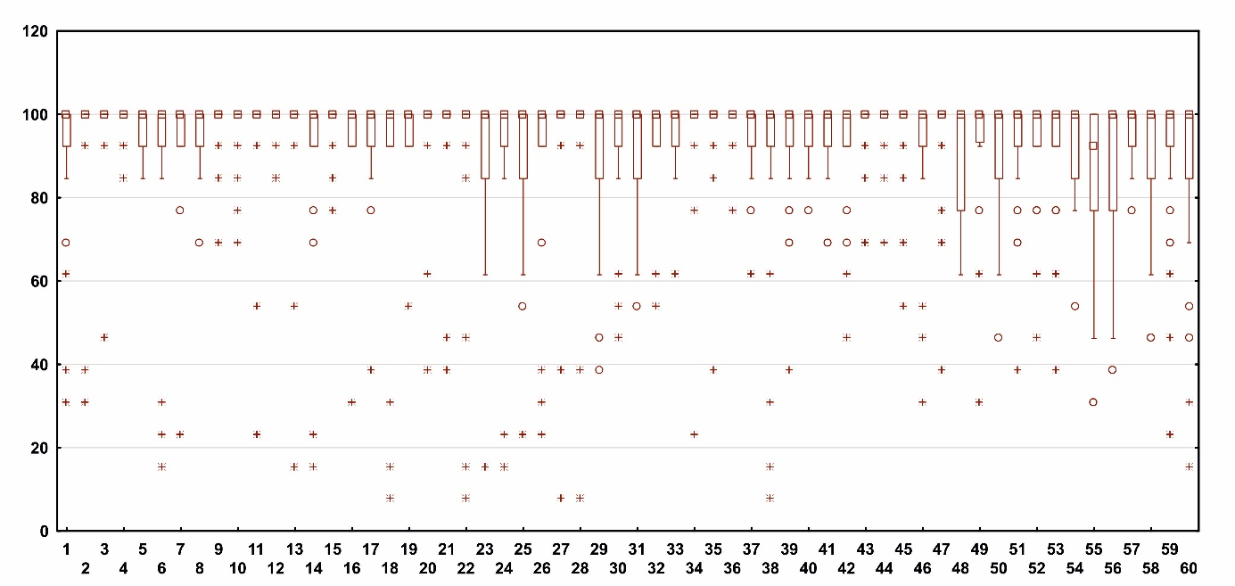

Fig. 17. The box-and-whisker diagram with extreme values, outliers, median and non-outlier range (25%-75%), obtained for photomicrographs (1 to 60) in thermally and oxidatively altered coals in the 2018 Round Robin Exercise.

**Based on the arithmetic mean, the best results were recorded for photomicrograph 36 (98.46%) and the worst for photomicrographs 23 (82.15 %), 26 (83.70%) and 13 (84.31%). The statistical mode, or the most common numbers in the data set refers to the value of 100% and occurred in 34, 35 and 36 (numerical account of mode: 22). The lowest numerical account of 11 was obtained for the photomicrograph 55. The lowest range, i.e., the best recognizability was calculated for photomicrographs 4, 5 and 12 with the range of 15.40 and 15, 36, 40 and 57 with the range of 23.10. The highest range was documented for photomicrographs 18, 22, 27, 28 and 38 with a range of 92.30 and for 6, 13, 14, 23, 24, 60 with a range of 84.60. The variance and standard deviation are not referred to as all data sets display non normal distribution. The highest variation coefficient was obtained for 23, 14 and 24 as well as 14 and the lowest for 4, 5, 36 and 12 photomicrographs.**

**Based on the** box-and-whisker diagram for Levels 1 to 6 displayed in Fig. 18, the highest range is observed in the Levels 2, 3, and 4, whereas the highest IQR is noted for the Level 2.

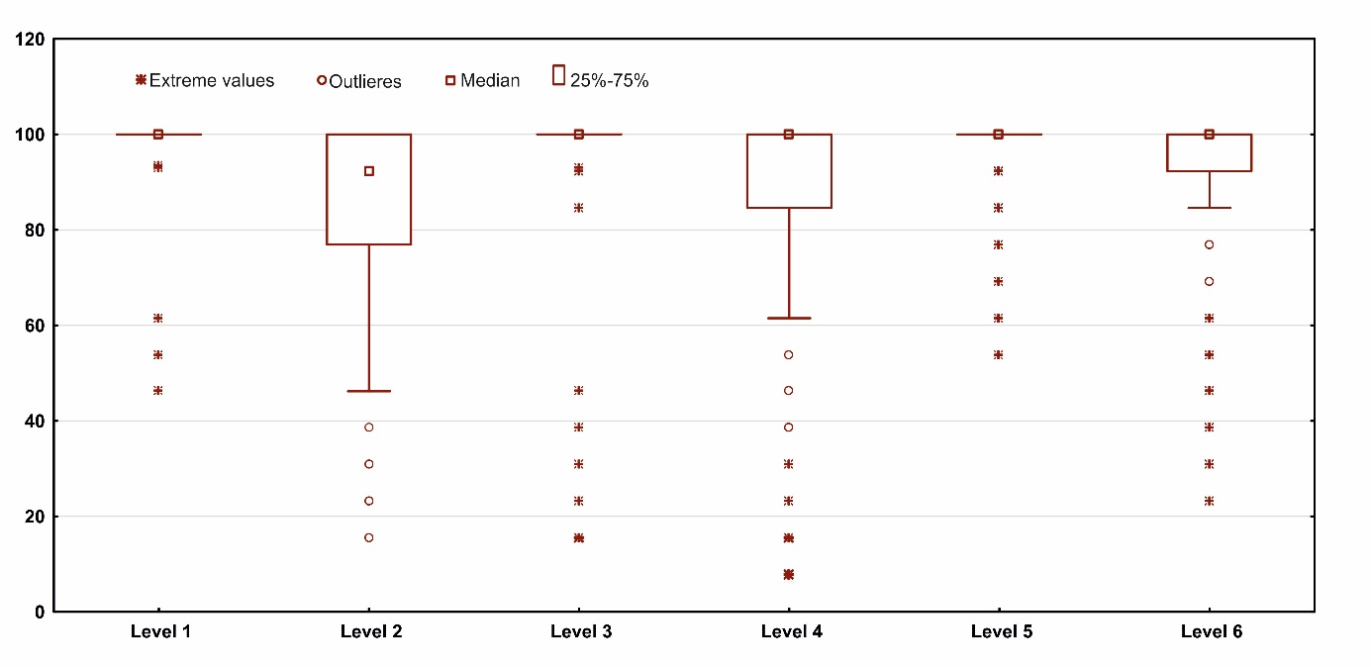

Fig. 18. The box-and-whisker diagram with extreme values, outliers, median and non-outlier range (25%-75%), obtained for 60 photomicrographs grouped into levels (1 to 6) in thermally and oxidatively altered coals in the 2018 Round Robin Exercise.

**Conclusion drawn from the evaluation with respect to forms as identified in each of the photomicrographs:**

* **Based on the arithmetic mean, the best recognizable forms were recorded for photomicrograph 36 (98.46%) and the worst for photomicrographs 23 (82.15 %) and 26 (83.70%) as well as 13 (84.31%).**
* **However, based on the range, the best recognizable forms were displayed in photomicrographs 4, 5 and 12 with the range of 15.40 and worst recognizable forms were seen in photomicrographs 18, 22, 27, 28 and 38 with a range of 92.30.**

5.5 Remarks from Participants

Participants made numerous comments and suggestions, which are displayed as follows:

* Select only one maceral to be identified.
* Clear images (not diffused).
* Polarised and fluorescence images are required.
* Apply the term reflectance to values measured in coke (not vitrinite reflectance!).
* Charred particles without a characteristic shape of chars – provide some additional information.
* Description of plasticised edges and bands require more explanation.
* Characterisation of inherent and thermal cracks: perpendicular to bedding, with and without bifurcations, extending through bands of inertinite, etc…
* Cracks were not filled. In Pict. 16. it is mineral matter.
* Do we need to consider Level 4 and Level 5 also for the newly formed particles?

**Acknowledgment:**

The Convenors of the Self-Heating WG would like to thank all Participants for participation in the 2018 IDOM Round Robin Exercise and for providing detailed descriptions of the observed optical characteristics of coals subjected to oxidative and thermal alteration. The author is very grateful to Mihaela Balanescu, Faculty of Physics, Bucharest University, Romania and Ewa Szram, Faculty of Natural Resources, University of Silesia, Katowice, Poland for great support in statistical evaluations of the data.

**References:**

Alpern B., Lemos de Sousa M.J., Pinheiro H.J., Zhu X.,1992. Optical morphology of hydrocarbons and oil progenitors in sedimentary rocks – relations with geochemical parameters. Publicações do Museu e Laboratório Mineralógico e Geológico da Faculdade de Ciências do Porto.  N. S. 3, 1–21.

International Committee for Coal and Organic Petrology, (ICCP), 1998. The new vitrinite classification (ICCP System 1994). Fuel 77, 349–358.

International Committee for Coal and Organic Petrology, (ICCP), 2001. The new inertinite classification (ICCP System 1994). Fuel 80, 459–471.

Kwiecińska B., Petersen H.I., 2004. Graphite, semi-graphite, natural coke, and natural char classification—ICCP system. International Journal of Coal Geology 57, 99–116.

Misz-Kennan, M., Kus, J., Flores, D., Avila, C., Buckun, Z., Choudhury, N., Christanis, K., Joubert, J.P., Kalaitzidis, S., Karayigit, A.I., Malecha, M., Marques, M., Martizzi, P., O'Keefe, J.M.K., Pickel, W., Predeanu, G., Pusz, S., Ribeiro, J., Rodrigues, S., Singh, A.K., Suarez-Ruiz, I., Sykorova, I., Wagner, N.J., Životić, D., ICCP. 2020. Development of a petrographic classification system for organic particles affected by self-heating in coal waste. (An ICCP Classification System, Self-heating Working Group – Commission III). International Journal of Coal Geology 220, 103411.

Pickel W., Kus J., Flores D., Kalaitzidis S., Christanis K., Cardott B.J., Misz-Kennan M., Rodrigues S., Hentschel A., Hamor-Vido M., Crosdale P., Wagner N. , ICCP, 2017. Classification of liptinite – ICCP System 1994. International Journal of Coal Geology 169, 40–61.

Predeanu, G. Panaitescu, C., Bălănescu, M., Bieg, G., Borrego, A.G., Diez, M.A., Hackley, P., Kwiecińska, B., Marques, M., Mastalerz, M., Misz-Kennan, M. Pusz, S., Suárez Ruiz, I., Rodrigues, S., Singh, A.K., Varma, A.K., Zdravkov, A., Životić, D., 2015. Microscopical characterization of carbon materials derived from coal andpetroleum and their interaction phenomena in making steel electrodes,anodes and cathode blocks for the Microscopy of Carbon MaterialsWorking Group of the ICCP. International Journal of Coal Geology 139, 63–79.

Suárez-Ruiz, I., Crelling, J.C., 2008. Applied coal petrology. The role of petrology in coal utilization. Elsevier, Academic Press, 388 p.

Sýkorová I., Pickel W., Christianis K., Wolf M., Taylor T.G., Flores D., 2005. Classification of huminite - ICCP System 1994. International Journal of Coal Geology 62, 85–106.

Taylor G.H., Teichmüller M., Davies A., Diessel C.F.K., Littke R., Robert P., 1998. Organic Petrology. Gebrüder Borntraeger, Berlin, 704 p.

Uebersax, J., 2001. Statistical Methods for Rater and Diagnostic Agreement. <http://www.john-uebersax.com/stat/raw.htm>.