2016 | International Committee  for Coal and Organic Petrology | Methods
 | ELECTRON MICROSCOPY

Chapter 8: Electron microscopy methods: application of TEM and SEM for analysis of coals, organic-rich shales and carbonaceous matter

Barbara Kwiecińskaª, Sławomira Pusz^{b}, Brett J. Valentine^{c}

a) AGH-University of Science and Technology, Aleja Mickiewicza 30, PL-30059 Kraków, Poland
b) Centre of Polymer and Carbon Materials, Polish Academy of Sciences, M. Curie- Sklodowskiej 34, PL- 41819 Zabrze, Poland
c) U.S. Geological Survey Microanalysis Laboratory, 956 National Center, Reston, VA, 20192, USA

Introduction
The following paper outlines the principles of both transmitted (TEM) and scanning electron (SEM) microscopy methods for analysis of coals, organic-rich shales, and carbonaceous matter. Additionally, the chapter provides an overview of the history of electron microscopy, procedures and considerations needed during specimen preparation and examples of TEM/SEM applications. The methods presented were developed in collaboration with the International Committee for Coal and Organic Petrology (ICCP) as part of the ICCP Methods Handbook.

Keywords: transmission electron microscopy (TEM); scanning electron microscopy (SEM); specimen preparation; coal; organic-rich shales; carbonaceous matter

8.12. ELECTRON MICROSCOPY

Electron microscopes were developed due to the limitations of light microscopes to about 300 nm resolution and useful magnifications below 2000x. An electron microscope uses a particle beam of electrons instead of visible light to illuminate the specimen and produce a magnified image. Because electrons have deBroglie wavelengths about 100,000 times shorter than visible light, electron microscopy can achieve 0.05 nm resolution and magnifications of up to about 10,000,000x. There are two main types of electron microscopes: scanning electron microscope (SEM) and transmission electron microscope (TEM), and recently also Scanning Transmission Electron Microscope (STEM), corresponding to reflected light and transmitted light microscope, respectively.

As the beam of electrons penetrate the sample, they cause the emission of electrons with different energy spectra and other radiations (Fig. 1), which contain information about the sample's surface topography, crystallographic structure, chemical composition and other properties, e.g., electrical conductivity. Each emission mode is potentially a signal, from which various images of the sample can be formed.

The development of electron microscopy, coupled with improved analytical methods have expanded our capabilities to better explore and understand coal and carbonaceous matter. These mainly include examination of the morphology and chemical composition of coal petrographic components and the study of the arrangement of aromatic layers in determining coal or carbonaceous matter textures (i.e. types, modes of occurrence, distribution). Electron microscopy have also helped to explore the physical and chemical composition of minerals and other inorganic components, including trace elements coexisting with organic matter as well as the characterization of microstructures within source rocks and reservoirs, especially their nano-scale porosity.

8.12.1. TRANSMISSION ELECTRON MICROSCOPY (TEM)

The first type of electron microscope was a transmission electron microscope (TEM) constructed by Max Knoll and Ernst Ruska in 1931. It was patterned exactly on the light transmission microscope except that a parallel beam of electrons was used instead of light to “image” the specimen and gain information. Currently, a 400 kV TEM provides the highest resolution below 0.2 nm and allows for the observation of relatively thick samples. Advanced STEM instruments can achieve 0.05 nm resolution.

Each TEM consists of the following basic elements (Fig. 2): the electron gun (tungsten filament, LaB6 or field emission) producing a stream of electrons, which is focused into a small, thin, parallel electron beam by the use of condenser lenses (C1 and C2) and condenser aperture. This beam strikes the specimen of proper thickness and part of it is transmitted. The transmitted portion is focused by the objective lens into an image. The image is passed down the column through the intermediate and projector lenses, being enlarged all the way. The strength of lenses and, in as a consequence, the magnification can be varied smoothly. Magnetic lenses, similar to glass lenses, have some types of aberration: spherical aberration (the magnification in the center of the lens differs from that at the edges), chromatic aberration (the magnification of the lens varies with the wavelength of the electrons in the beam) and astigmatism (the beam is not a perfect circle in cross section), which must be corrected to obtain good image. If the specimen is crystalline there will be a diffraction pattern at a different point in the lens known as the back focal plane.

The image is projected onto a fluorescent screen and the light is generated, allowing the user to see the image through a large window in the projection chamber. TEM images can be recorded on negative films, on imaging plates or, the most often, on slow-scan CCD cameras making them suitable for subsequent enhancement and analysis.

Usually the image originates from various depths within the specimen. Therefore it is not sufficient to move the specimen only in the horizontal plane. It is necessary to tilt the specimen, to rotate and define the axis of tilt. This movement is extremely important, especially for crystalline specimens, in order to obtain the required diffraction pattern. These requirements can be fulfilled by a device called a goniometer. The goniometer is mounted very close to the objective lens and provides motorized X, Y and Z movement and tilt around one axis.

Modern electron microscopes employ fast and powerful computers to control and record the operating conditions of the microscope and to support extended data acquisition for analytical applications.

The development of new technologies enables modern transmission electron microscopy to include a wide range of different methods that use the various signals arising from the interaction of the electron beam with the sample (Fig. 1) to obtain information about structure, morphology and composition of materials (Fig. 1). The most common are:
• Bright Field (BF)/Dark Field (DF)
• High Resolution Transmission Electron Microscopy (HRTEM)
• Electron Diffraction (ED)
• Scanning Transmission Electron Microscopy (STEM)
• X-ray Spectroscopy (EDXS)
• Energy Filtered Transmission Electron Microscopy (EFTEM)
• Electron Energy Loss Spectroscopy (EELS)

TEM is an appropriate technique to examine structural units in all kinds of organic matter including graphite. This examination can yield the following information: topography, morphology, composition and crystallographic features. In the last case, TEM is a complementary tool to conventional crystallographic methods such as X-ray diffraction. TEM is a very powerful tool for the quantitative characterization of materials micro and nanostructure and their local chemical composition. However, it should not be used in isolation to solve a material problem.

Electron diffraction has the unique advantage over XRD in that it combines in the same instrument and on the same sample area, morphological, crystallographic and chemical information. Selected area electron diffraction and nano-diffraction are complementary. Electron diffraction patterns can be obtained from relatively small volumes of material compared with X-rays and neutrons. Electron diffraction of amorphous materials has a number of advantages over X-rays. Amorphous materials are not crystalline, but have some short range order, which is revealed by electron diffraction.

In scanning transmission electron microscopy (STEM), the condenser lenses of the microscope demagnifies the electron probe to form a small electron beam. This electron beam scans a defined area of the sample. At each spot, the generated signal is simultaneously recorded by selected detectors, building up an image. Furthermore, such a convergent beam is used to gain a highly localized signal from the specimen in analytical TEM (e.g., EDXS, EELS) and thus the combination of STEM with other analytical methods is a valuable technique for analytical work.

The extension of traditional transmission electron microscopy is TEM tomography. This technique allows creating a 3D image of the sample using a sequence of TEM images taken at different tilts of the specimen around a single axis.
Specimen preparation

The quality of TEM results strongly depends on the quality of the specimen.

The specimen should be stable and small enough (some 3 millimeters in diameter) to permit the introduction into the evacuated microscope column, and sufficiently thin (from about 0.5 micrometers to less than 100 nm) to be transparent to electrons. For carbonaceous matter TEM requires objects less than a few thousands Angstroms thin.

Every branch of research has its own specific methods of preparing the samples for electron microscopy. The selection of a proper preparation method depends on the material itself and on the kind of information that is desired.

- Powdered samples:

The sample is fine-ground in ethanol, then it is dispersed and dropped on the surface of distilled water and as a suspension it is fixed on an amorphous carbon or collodion film deposited on a copper grid. The sample is ready after evaporation of water in a dessicator.

Details can be found in several papers: Oberlin et al. (1980), Oberlin (1984), Henning and Storr (1986), Rouzaud and Oberlin (1983, 1985, 1990), Jehlicka and Rouzaud (1993), Taylor et al. (1998).

- Ultra-microtome:

From specimens that have strong electron scattering, thin-cut sections can be made for direct transmission, using an ultra-microtome equipped with a diamond knife. Specimen blocks are trimmed to fit each shape according to particular orientation requirement. Ultrathin sections are placed on carbon coated or formvar covered copper grids (200-300 mesh). The method is outlined by Taylor (1966), Glikson and Taylor (1986), Taylor et al. (1991), Taylor and Teichmüller (1993). Special application of this method is described by Uwins et al. (2000).

- Focused Ion Beam:

The most modern technique of sample preparation for TEM is focused ion beam (FIB). In this apparatus Ga+ beam is used for selective removal of material by ion beam milling to obtain very thin samples. FIB is also a microscope, which allows the operator to control the process of cutting of the specimen.

- Ion milling, electropolishing and lithography:

These methods are used to complete the TEM specimen preparation process by non- mechanically thinning previously dimpled specimens until become electron transparent (less than 200 nm).

- Replicas:

For a closer observation of surface textures, different replica techniques can be used. There are one-stage (negative) and multi-stage (positive) replicas. For the investigation of organic matter one-stage replicas with Pt-shadowing and carbon backing are most commonly used. They are taken from natural specimen surfaces or cleavage faces.
This technique allows the extraction of small fragments/particles or micro-fibers from the surface and to examine them by other techniques including diffraction pattern if they are crystalline and transparent to the electron beam (Kwiecinska, 1980; and others).

Before the development of ultra-microtomes and focused ion beam, the replica techniques were very popular. Presently they are applied only occasionally.

Examples of the application of TEM for coal and carbon material studies.

High resolution transmission electron microscopy (HRTEM) is an excellent method for the examination of the dimensions and the arrangement of aromatic layers in all varieties of organic matter, comprising coals of different rank (Fig. 3, 4), derived from different sources. HRTEM has provided new information on the ultrafine structure of coal and coaly kerogen and its structural development during coalification (Oberlin et al., 1980). Particularly in the carbonaceous matter of high molecular ordering (shungite, thucholite, anthraxolite) the internal structure and texture, e.g., lattice fringes derived from aromatic layers, structural homo- or heterogeneity, degree of maturation (meta-anthracites, semi-graphites, graphites) and intimate association of organic matter with minerals on a sub-micron level – not distinguishable in light microscopy, can be detected by using HRTEM (Oberlin and Terriere, 1975; Crawford and Marsh, 1977; Rouzaud and Oberlin, 1983; Oberlin,
1989; Jehlicka and Rouzaud, 1993; Taylor et al., 1998; Kwiecińska and Petersen, 2004, Pusz et al., 2014). Minerals in coals can be identified by X-ray energy dispersive spectrometry (EDS) (Glikson et al., 2000).

HRTEM combined with electron tomography made it possible to obtain 3D images of structures of carbon materials, and is applied specially for the investigation of ultrafine structured carbon materials like carbon blacks, carbon foams, fullerenes, carbon nanofibres and nanotubes (Fig. 5) (Bourrat, 2000; and literature therein).

HRTEM combined with electron diffraction techniques has led to establishing the model of coking and graphitization process (Rouzaud and Oberlin, 1985; Oberlin, 1989; Rouzaud and Oberlin, 1990).

TEM images (BF and DF modes, Fig. 6, 7) were used to develop the method of quantification of coke texture (Bourrat et al., 1986; Bourrat, 2000). This method was further advanced allowing for the determination of the average molecular oriented domains (SMOD) reflecting the structure of the solid phase of porous carbon materials, e.g. cokes (Krzesinska et al., 2009; Pusz et al., 2010, Smędowski and Krzesińska, 2013).

TEM techniques have also allowed for the development of ultrastructural investigations in the field of palynology, paleobotany and micropaleontology (e.g. Glasspool et al., 2009; Hemsley and Scott, 1991; Okoli and Nyananyo, 1988; Van Campo and Lugardon, 1973) which are very useful in paleoenvironmental and paleofacial studies of coal basins.

8.12.2 SCANNING ELECTRON MICROSCOPY (SEM)

Scanning electron microscope (SEM) is an instrument that produces a largely magnified image by using electrons instead of light waves. Pioneering work on the physical principles of the SEM and beam-specimen interactions was performed by Manfred von Ardenne in 1937. The first SEM was constructed in 1942 by three researchers at RCA Labs in New Jersey, USA, Drs Zworykin, Hillier and Snyder, and had a resolving power of 50 nm and a magnification of 8,000x. The first commercial SEM was built in 1965 by Cambridge Scientific Instruments (UK) after the work of the Charles Oatley team (1948-1963). Nowadays SEMs can have a resolving power of less than 1 nm and can magnify over 400,000x.

The benefits of SEM over conventional light microscopy include very high resolution and a dynamic magnification range (better than 10x to 400,000x), greater depth of field (ability to image rough sample surfaces) and microanalysis – the ability to analyze the chemical composition of samples in detail (Wells, 1974).

All SEMs consist of an electron column that generates a beam of electrons; a sample chamber, where the electron beam interacts with the sample; detectors monitoring a variety of signals that result from beam-sample interaction, and a viewing system that constructs an image from the signal. The electron column consists of an electron gun (tungsten, LaB6 or field emission), a series of magnetic lenses, beam-defining apertures and a set of scanning coils (Fig. 8). An electron gun at the top of the column generates the electron beam. Magnetic lenses form a fine convergent beam of electrons that scans the surface of the specimen row by row. The collected signals are properly amplified and digitized while keeping a strict correspondence between sample scanned point and image point, to generate a real-time image viewed in a display screen that can be stored in a computer. The final image is built pixel by pixel (raster), from the number of electrons (or other radiation like X-rays, photons) emitted from each spot on the sample. The SEM image is produced from the signals generated from the surface of fragments or sections of specimens, which may have a size of several square millimeters or centimeters. The beam of electrons affecting the sample causes the emission of electrons with various energies and other kinds of radiation, which provide information about the sample’s surface morphology, composition, crystallographic structure and other properties.

Images in the SEM can be classified as follows:

- secondary electron (SE) image –generally the most useful type of image for studying surface topography. The secondary electron image is very similar in appearance to a light optical image, except there is no color and both the resolution and the depth of focus are greatly improved.
- backscattered electron (BSE) image – obtained by collecting primarily electrons that leave the specimen with more than 50 eV energy, as the result of elastic collision with the nuclei of sample atoms. The contrast in BSE image originates from differences in the average atomic number of the atoms being excited, thus it can provide important information about sample composition. With specialized detectors (EBSD) and properly prepared samples, the backscattered electrons can be used to study the local crystallographic structure (electron backscattered diffraction), and generate phase and grain orientation images (OIM).
- X-ray image (EDS or WDS) – obtained by collecting the characteristic X-rays that can be used to display the quality, quantity and distribution of chemical elements in the specimen.
- cathodoluminescence image - obtained by collecting the light emission by cathodoluminescent phases in the sample, with information related to trace element composition and structural defects.

Although standard SEMs have great advantages, i.e. superior resolution, depth of field and microanalytical capabilities, they also have a number of limitations, mainly derived from the high vacuum that must be maintained in the specimen chamber. Thus, samples for study must comply with high vacuum requirements, i.e. be vacuum tolerant, and electrically conductive. In practice, most samples do not meet these criteria and either need special preparation (basically, removing all water, solvents or gases that could vaporize while in the vacuum and coating with electrically conductive layers to avoid charging artifacts) or cannot be investigated by SEM. The above problems have been resolved by a new SEM generation – low vacuum and environmental SEM (ESEM). In these instruments, multiple Pressure Limiting Apertures (PLAs) separate the column from the sample chamber; the column remains at high vacuum, whereas the chamber may sustain pressure up to 200 Pa (low vacuum SEM) and to 4000 Pa (ESEM). The balance of gas flow into and out of the sample chamber determines its pressure. In low vacuum SEM high resolution imaging is still possible.
Low vacuum SEM allows the examination of specimens without restrictions concerning conductivity (nonconductive-uncoated specimens) and strict high vacuum compatibility, while retaining high resolution. Additionally, ESEM allows the examination of practically any specimen under a broad range of gaseous conditions (nonconductive-uncoated specimens, hydrated or contaminating samples) and the observation of in-situ dynamic experiments taking place in the microscopic chamber (phase transition, hydration, oxidation, corrosion and other thermal, mechanical and chemical processes).
Modern SEMs employ a fast, powerful computer enabling extended automation for imaging applications and specially for all the analytical operation modes, namely X-ray microanalysis and electron backscattered diffraction (EBSD).

Preparation technique:

1. Dimensions of the specimen should be suitable to put it into specimen chamber.
2. The fragments of specimen should have such a shape that the area to be imaged can be positioned parallel to the upper face of the specimen holder. If this is not possible the sample may be tilted in the SEM during examination to reduce focus issues across the examination surface.
3. In bedded specimens, such as coals, the samples should be prepared parallel as well as vertical to the layers, especially when the texture is to be investigated.
4. The specimen should be fixed to the holder using a conductive, vacuum-proof adhesive so that specimen and holder are firmly connected. After the specimens have been fixed, any particles that may adhere should be removed using purified compressed air.
5. Non-conductive and low-conductive specimens should be provided with a carbon or metal coat using one of the vacuum evaporation techniques. The main purpose of the coating is to increase the yield of secondary electrons and to enhance resolution, since due to increased conductivity, electron energies of 10-30 kV can be used, and local charge build- up on the specimen surface is avoided. Conductive coating is not necessary in case of using low vacuum SEM or an ESEM apparatus.

Sometimes additional treatment of the specimen surface is necessary to enhance contrast or expose inner details such as etching (chemical, ion-beam), etching by low temperature ashing, electrolysis, decoration. The simple and pressure moulding methods can be applied to coke, fly ash, and other carbonaceous materials, as well as to coal. Many specific procedures of sample preparation for SEM studies are presented in the handbook of P. Echlin (2009).

Examples of the application of SEM for coals, organic-rich shales, and carbon materials studies.

The introduction of various SEM techniques has greatly benefited the studies of coals, carbonaceous matter and carbon materials and has been presented in many papers. The SEM is commonly used for structural investigation of high rank coals and carbon materials (Gornostayev and Harkki, 2006; Kwiecińska et al., 1992; Legin-Kolar et al., 1999). It is an appropriate technique for studying tonsteins and a good complementary technique in paleopalynology, palaeobotany and micropaleontology (e.g. Glasspool et al., 2009; Hemsley and Scott, 1991; Taylor et al., 1968, 2009 Traverse, 2009). SEM microprobe (X-ray microanalysis) made important progress in the study of coal maceral chemistry (e.g. Bustin et al., 1996; Gurba and Ward, 2000; Mastalerz and Gurba, 2001; Ward and Gurba , 1998; 1999; Ward et al., 2005) as well as mineral matter associated with peat and coal (e.g. Creelman and Ward, 1996; Kalaitzidis and Christanis, 2003; Li et al., 2007; Permana et al., 2013; Ward et al, 1996).

With the increased interest in unconventional oil and gas petroleum systems worldwide, electron microscopy has played an important role in characterizing microstructures of source rocks and reservoirs (Chalmers et al., 2012; Curtis et al., 2012; Cardott et al., 2015; Lu et al., 2015). The high resolution achieved with modern FE-SEMs coupled with ion milling (e.g., broad-ion-beam, focused-ion-beam) has enabled scientists to examine nano-scale porosity of dispersed organic material, as well as within the mineral matrix of shales and mudrocks (Loucks et al., 2009). Most studies indicate that as the thermal maturity of organic-rich shales increases, generating hydrocarbons, the development of secondary pores in organic matter also increases (Jarvie et al., 2007; Bernard et al., 2012a and b; Chalmers et al., 2012; Modica and Lapierre, 2012). However, some studies have not been able to document this trend (Fishman et al., 2012; Milliken, 2013), supporting the idea that development of organic porosity could be affected by several factors (i.e., organic matter/maceral type, burial history, mineral interactions, TOC content). In particular, the mineral matrix may exert an important control for organic porosity preservation. For example, the study by Fishman et al. (2012) did not reveal any organic porosity preserved in mature organic-rich Kimmeridge Clay Formation, a lack which they suggested was due to plasticity and deformation of the clay-rich inorganic matrix.

One hurdle using electron microscopy that has hindered organic porosity research is its inability to adequately identify dispersed organic macerals (Hackley and Cardott, 2016). Traditional organic petrology techniques use optical microscopy to identify macerals based on reflectance, form/shape, relief, and fluorescence, while SEM exhibits contrast in relief (SE), atomic number (BSE), and in most cases the form/shape of organic material (Stanton and Finkelman, 1979). Cardott and Curtis (2016) found that examining coal samples using low accelerating voltages (1-2kV) resulted in low grey scale contrast (BSE) between macerals making identification difficult, whereas higher accelerating voltages (10kV) yielded higher contrast between maceral groups (vitrinite, inertinite and liptinite), with some ability to distinguish maceral subgroups (telovitrinite vs. detrovitrinite) or even macerals (sporinite vs. cutinite). Their study also found that the identification based solely on contrast between the different inertinite macerals (semifusinite, fusinite, macrinite) was difficult unless the maceral had bogen structure (fusinite vs. semifusinite), and this also extended to the identification of inertinite vs. vitrinite in shale samples, where little to no grey-scale contrast could be used to distinguish between the maceral groups. Valentine and Hackley (2016) compared correlative reflected light (white and blue light) with SE and BSE (5kV, low current intensity, 5 mm WD) and found that in a low maturity Bakken Formation (solid bitumen R_{o} 0.3%) sample, no grey scale distinctions could be made between adjacent amorphous organic material, solid bitumen and inertinite with the exception of inertinites with high R_{o} (3.25% R_{o}) and arch structures (Fig. 15). Furthermore Bernard et al. (2012a and b) used the C-XANES spectra from synchrotron-based scanning transmission X-ray microscopy (STXM) with STEM images on shale samples to identify different organic matter types (kerogen, bitumen, and pyrobitumen). Efforts by Loucks and Reed (2014) focused on the processing of SEM photomicrographs to distinguish organic matter types as depositional (kerogen, solid bitumen, pyrobitumen) or migrated (solid bitumen, pyrobitumen) using the form/shape of the organic material, pore size/textures/shape, and the examination of adjacent mineral cementation to determine depositional origin. Their distinction between depositional vs. migrated organic material could help to understand the pore networks present in organic rich shales, as depositional organics tend to have a limited pore network compared to migrated organic material. As correlative techniques continue to improve and with advances in SEM technology (i.e., low voltage microscopy, low pressure/environmental modes), electron microscopy will play an important role in evaluating nanoscale features in coal, shales, and other carbonaceous materials.

Until recently, SEM and TEM techniques have been usually used as complementary methods to other prominent techniques such as light microscopy, X-ray diffraction, Raman spectroscopy, etc. With the improvements made on the current generation of electron microscopes, SEM and TEM will continue to improve our understanding of micro-nanoscale physical and chemical characteristics. The combination of various electron microscopy methods coupled with analytical techniques can be sufficient to conduct full characterization of a wide variety of carbonaceous materials (Cutruneo et al., 2014; Saikia et al., 2014; Yossifova, 2014).

Acknowledgements

The authors thank very much Dr. Stavros Kalaitzidis and Dr. Deolinda Flores from the ICCP
for their efforts to improve this paper.

References

Arbuzov, S.I., Mezhibor, A.M., Spears, D.A., Ilenok, S.S., Shaldybin, M.V., Belaya, E.V., 2016. Nature of tonsteins in the Azeisk depositof the Irkutsk Coal Basin (Siberia, Russia). Int. J. Coal Geol. 153, 99-111.
Bernard, S., B. Horsfield, H.-M. Schulz, R. Wirth, A. Schreiber, and N. Sherwood, 2012. Geochemical evolution of organic-rich shales with increasing maturity: A STXM and TEM study of the Posidonia Shale (Lower Toarcian, northern Germany): Marine and Petroleum Geology, v. 31, p. 70-89.
Bernard, S., R. Wirth, A. Schreiber, H.-M. Schulz, and B. Horsfield, 2012. Formation of nanoporous pyrobitumen residues during maturation of the Barnett Shale (Fort Worth Basin): International Journal of Coal Geology, v. 103, p. 3-11.
Bourrat, X., 2000. Structure in Carbons and carbon Artifacts. In: H. Marsh, F. Rodriques- Reinoso (Eds.), Sciences of Carbon Materials. Univ. de Alicante, p. 1-97.
Bourrat, X., Oberlin, A., Escalier, J.C., 1986. Microtexture and structure of semi-cokes and cokes. Fuel 65, p. 1490-1500.
Cardott, B.J., Landis, C.R., Curtis, M.E., 2015. Post-oil solid bitumen network in the Woodford Shale, USA — A potential primary migration pathway: International Journal of Coal Geology, v. 139, p. 106-113.
Cardott, B.J., Curtis, M.E., 2016. Primary and secondary pores of kerogen and bitumen by reflected light and scanning electron microscopy. SEPM/AAPG Hedberg Research Conference Mudstone Diagenesis, October 16-19, 2016, Santa Fe, NM, USA. p. 146-147.
Chalmers, G.R., R.M. Bustin, and I.M. Power, 2012. Characterization of gas shale pore systems by porosimetry, pycnometry, surface area, and field emission scanning electron microscopy/transmission electron microscopy image analyses: Examples from the Barnett, Woodford, Haynesville, Marcellus, and Doig units: AAPG Bulletin, v. 96, p. 1099-1119.
Crawford, D., Marsh, H., 1977. High resolution electron microscopy of carbon structure.
Journal of Microscopy 109/1, p. 145-152.
Creelman, R.A., Ward, C.R., 1996. A scanning electron microscope method for automated, quantitative analysis of mineral matter in coal. International Journal of Coal Geology 30, p. 249-269.
Curtis, M.E., B.J. Cardott, C.H. Sondergeld, and C.S. Rai, 2012. Development of organic porosity in the Woodford Shale with increasing thermal maturity: International Journal of Coal Geology, v. 103, p. 26-31.
Cutruneo, C.M.N.L., Oliveira, M.L.S., Ward, C.R., Hower, J.C., de Brum, I.A.S., Sampaio, C.H., Kautzmann, R.M., Taffarel, S.R., Teixeira, E.C., Silva, L.F.O., 2014. A mineralogical and geochemical study of three Brazilian coal cleaning rejects: Demonstration of electron beam applications. Int. J. Coal Geol. 130, 33-52.
Dai, S., Wang, X., Zhou, Y., Hower, J.C., Li, D., Chen, W., Zhu, X., Zou, J., 2011. Chemical and mineralogical compositions of silic, mafic, and alkali tonsteins in the Late Permian coals from the Songzao Coalfield, Chongquing, Southwest China. Chemical Geol. 282, 29-44.
Dai, S., Li, T., Seredin, V.V., Ward, C.R., Hower, J.C., Zhou, Y., Zhang, M., Song, X., Song, W., Zhao, C., 2014. Origin of minerals and elements in the Late Permian coals, tonsteins, and host rocks of the Xinde Mine, Xuanwei, eastern Yunnan, China. Int. J. Coal Geol. 121, 53-78
Duber, S., 2011. Nanostruktura i mikrotekstura antracytów. Wydawnictwo Uniwersytetu Śląskiego. Katowice.
Echlin, P., 2009. Handbook of sample preparation for scanning electron microscopy and X-ray microanalysis. Springer.
Fishman, N.S., P.C. Hackley, H.A. Lowers, R.J. Hill, S.O. Evenhoff, D.D. Eberl, and A.E. Blum, 2012. The nature of porosity in organic-rich mudstones of the Upper Jurassic Kimmeridge Clay Formation, North Sea, offshore United Kingdom: International Journal of Coal Geology, v. 103, p. 32-50.
Glasspool, I.J., Collonson, M.E., Scott, A.C., Brain, A.P.R., Plotnick, R.E., Kenig, E., 2009. An ultrastructural investigation of early Middle Pennsylvanian megaspores from the Illinois Basin, USA. Review of Palynology and Paleobotany 156, 62-78.
Glickson, M., Taylor, G.H., 1986. Cyanobacterial mats: major contributors to the organic matter in Toolebue Formation oil shales. Geol. Soc. Austral., Spec. Publ. 12, p. 273-286.
Glikson, M., Golding, S.D., Boreham, C.J., Saxby, J.D., 2000. Mineralization in eastern Australia coals: a function of oil generation and primary migration. In: M. Glikson, M. Mastalerz (Eds.), Organic matter and mineralization: thermal alteration, hydrocarbon generation and role in metallogenesis. Kluwer Acad. Publ.
Gornostayev, S., Harkki, J., 2006. Mineral matter crystallization and crack formation in tuyere coke. Fuel 85, p. 1047-1051.
Gurba, L.W., Ward, C.R., 2000. Elemental composition of coal macerals in relation to vitrinite reflectance, Gunnedah Basin, Australia, as determined by electron microprobe analysis. International Journal of Coal Geology, v. 44, p.127-147.
Hackley, P.C., Cardott, B.J., 2016. Application of organic petrography in North American shale petroleum systems: a review. International Journal of Coal Geology, v. 163, p. 8-51.

Hemsley, A.R., Scott, A.C., 1991. Ultrastructure and relationships of upper carboniferous spores from Thorpe Brickworks, West Yorkshire, U.K. Review of Paleobotany and Palynology 69, 337-351.
Henning, K.H., Storr, M., 1986. Electron micrographs (TEM, SEM) of clays and clay minerals. Akademie-Verlag Berlin.
House A, Balkwill K. FIB-SEM: An additional technique for investigating internal structure of pollen walls. Microscopy and Microanalysis. 2013; 19:1535-1541.
Huff, W.D., Spears, D.A., 1989. A tonstein from the Lower Limestone Group of Arran. Scottish Journal of Geology 25, 161-172.
Jarvie, D.M., Hill, R.J., Ruble, T.E., Pollastro, R.M., 2007. Unconventional shale-gas systems: The Mississippian Barnett Shale of north-central Texas as one model for thermogenic shale-gas assessment. The American Association of Petroleum Geologists (AAPG) Bulletin, v. 91, no. 4, p. 475-499.
Jehlicka, J., Rouzaud, J.N., 1993. Transmission electron microscopy of Carbonaceous matter in Precambrian shungite from Karelia. In: J. Parnell, H. Kucha, R. Landais (Eds.), Bitumens in ore deposits. Springer-Verlag, p. 53-60.
Kalaitzidis, S. and Christanis, K., 2003. Scanning electron microscope studies of the Philippi peat (NE Greece): Initial aspects. Int. J. Coal Geol., 54. p.69-77.
Krzesinska, M., Pusz, S., Smędowski, Ł., 2009. Characterization of the porous structure of cokes produced from the blends of three Polish bituminous coking coals. International Journal of Coal Geology 78, p. 169-176.
Kwiecińska, B., 1980. Mineralogy of natural graphites. Prace mineralogiczne PAN, 67, 102 pp.
Kwiecińska, B., Hamburg, G., Vleeskens, J.M., 1992. Formation temperatures of natural coke in the Lower Silesian Coal Basin, Poland. Evidence from pyrite and clays by SEM-EDX. International Journal of Coal Geology 21, p. 217-235.
Kwiecińska, B., Petersen, H.I., 2004. Graphite, semi-graphite, natural coke, and natural char classification - ICCP System. International Journal of Coal Geology 57, p. 99-116.
Legin-Kolar, M., Radenovic, A., Ugarkovic, D., 1999. Changes in structural parameters of different cokes during heat treatment to 2400oC. Fuel 78, p. 1599-1605.
Li, Z., Ward, C.R., Gurba, L.W., 2007. Occurrence of non-mineral inorganic elements in low- rank coal macerals as shown by electron microprobe element mapping techniques. International Journal of Coal Geology 70, p. 137-149.
Loucks, R.G., R.M. Reed, S.C. Ruppel, and D.M. Jarvie, 2009. Morphology, genesis, and distribution of nanometer-scale pores in siliceous mudstones of the Mississippian Barnett Shale: Journal of Sedimentary Research, v. 79, p. 848-861.
Loucks, R.G., and R.M. Reed, 2014. Scanning-electron-microscope petrographic evidence for distinguishing organic matter pores associated with in-place organic matter versus migrated organic matter in mudrocks: Gulf Coast Association of Geological Societies Journal, v. 3, p. 51-60.
Lu, J., S.C. Ruppel, and H.D. Rowe, 2015. Organic matter pores and oil generation in the Tuscaloosa marine shale: American Association of Petroleum Geologists Bulletin, v. 99, p. 333-357.
Mastalerz, M., Gurba, L.W., 2001. Determination of nitrogen in coal macerals using electron microprobe technique – experimental procedurę. . Int. J. Coal Geol. 47, 23-30.
Milliken, K.L., M. Rudnicki, D.N. Awwiller, and T. Zhang, 2013. Organic matter-hosted pore system, Marcellus Formation (Devonian), Pennsylvania: AAPG Bulletin, v. 97, p. 177-200.
Modica, C.J., and S.G. Lapierre, 2012. Estimation of kerogen porosity in source rocks as a function of thermal transformation: Example from the Mowry Shale in the Powder River Basin of Wyoming: AAPG Bulletin, v. 96, p. 87-108.
Oberlin, A., 1984. Carbonization and graphitization. Carbon 22, 521–541.
Oberlin, A., 1989. High resolution TEM studies of carbonization and graphitization. In: P.A.
Thrower (Ed.), Chemistry and Physics of Carbon, 22, p. 1-143.
Oberlin, A., Boulmier, J.L., Villey, M., 1980. Electron microscopic study of kerogen microstructure. Selected criteria for determining the evolution path and evolution stage of kerogen. In: B. Durand (Ed.), Kerogen. Editions Technip, Paris, p. 191-241.
Oberlin, A., Terriere, G., 1975. Graphitization studies of anthracites by high-resolution electron microscopy. Carbon 13, p. 367-376.
Okoli, B.E., Nyananyo, B.L., 1988. Palynology of Telfairia L. (Cucurbitaceae). Folia Geobotanica at Phytotaxonomica 23, 281-283
Permana, A.K., Ward, C.R., Li, Z., Gurba, L.W., 2013. Distribution and origin of minerals in high-rank coals of the South Walker Creek area, Bowen Basin, Australia. Int. J. Coal Geol. 116-117, 185-207.
Pusz, S., Borrego, A.G., Alvarez, D., Camean, I., du Cann, V., Duber, S., Kalkreuth, W., Komorek, J., Kus, J., Kwiecińska, B., Libera, M., Marques, M., Misz-Kennan, M., Morga, R., Rodrigues, S., Smędowski, Ł., Suarez-Ruiz, I., Strzezik, J., 2014. Application of Reflectance Parameters in the Estimation of the Structural Order of Coals and Carbonaceous Materials. Precision and bias of measurements derived from the ICCP Structural Working Group International Journal of Coal Geology 131, p. 147-161.
Pusz, S., Krzesińska, M., Smędowski, Ł., Majewska, J., Pilawa, B., Kwiecińska, B., 2010. Changes in a coke structure due to reaction with carbon dioxide. International Journal of Coal Geology 81, p. 287-292.
Rodrigues, S., Marques, M., Suarez-Ruiz, I., Camean, I., Flores, D., Kwiecińska, B., 2013. Microstructural investigations of natural and synthetic graphites and semi-graphites. Int. J. Coal Geol. 111, 67-79.
Rouzaud, J.N., Oberlin, A., 1983. Contribution of high resolution transmission electron microscopy (TEM) to organic material characterization and interpretation of their reflectance, in: B. Durand (Ed.), Thermal Phenomena in Sedimentary Basins. Technip, Paris, p. 127-134.
Rouzaud, J.N., Oberlin, A., 1985. Raw and pyrolized coals: a preferential field for transmission electron microscopy. Proc. Int. Conf. Coal Science, Sydney, Austral. Pergamon Press, p. 657-660.
Rouzaud, J.N., Oberlin, A., 1990. The characterization of coals and cokes by transmission electron microscopy. In: H. Charcosset (Ed.), Coal science and technology, vol. 15. Elsevier, Amsterdam, p. 311-354.
Saikia, B.K., Ward, C.R., Oliveira, M.L.S., Hower, J.C., de Leao, F., Johnston, M.N., O’Bryan, A., Sharma, A., Baruah, B.P., Silva, L.F.O., 2014. Geochemistry and nano-mineralogy of feed coals, mine overburden, and coal-derived fly ashes from Assam (North-east India): a multi-faceted analytical approach. In. J. Coal Geol. 137, 19-37.
Smędowski, Ł., Krzesińska, M., 2013. Molecular oriented domains (MOD) and their effect on technological parameters within the structure of cokes produced from binary and ternary coal blends. International Journal of Coal Geology 111, p. 90-97.
Stanton, R.W., and R.B. Finkelman, 1979, Petrographic analysis of bituminous coal: optical and SEM identification of constituents: Scanning Electron Microscopy, 1979, part 1, p. 465-471.
Taylor, G.H., 1966. The electron microscopy of vitrinites. Coal Science. Adv. Chem., Ser. 55, p. 274-283.
Taylor, G.H., Liu, S.Y., Teichmüller, M., 1991. Bituminite – a TEM view. International Journal of Coal Geology 18, p. 71-85.
Taylor, G.H., Teichmüller, M., 1993. Observations on fluorite and fluorescent vitrinite with the transmission electron microscope (TEM). International Journal of Coal Geology 22, p. 61-82.Taylor, G.H., Teichmüller, M., Davis, A., Diessel, C.F.K., Littke, R., Robert, P., 1998. Organic Petrology. Gebrüder Borntraeger, Berlin-Stuttgart.
Taylor, T.N., 1968. Application of the Scanning Electron Microscopy in Paleobotany. Trans. Amer. Microsc. Soc., vol. 87, 511-515.
Taylor, T.N., Taylor, E.L., Krings, M., 2009. Paleobotany: The Biology and Evolution of Fossil Plants. Second edition. Elsevier.
Traverse A., 2009. Paleopalynology. Second edition. Springer
Uwins, P.J.R., Taylor, A.P., Webb, R.I., 2000. Nannobacteria, fiction or fact? In: M. Glikson, M. Mastalerz (Eds.). Organic matter and mineralization: thermal alteration, hydrocarbon generation and role in metallogenesis. Kluwer Academic Publ., p. 454.
Valentine, B.J., Hackley, P.C., 2016. Bridging the gap between optical and electron microscopy: The importance of correlative microscopy for understanding dispersed organic matter. SEPM/AAPG Hedberg Research Conference Mudstone Diagenesis, October 16-19, 2016, Santa Fe, NM, USA. p. 131-132.
Van Campo, M., Lugardon, B., 1973. Structure grenue infratectale de l'ectexine des pollens de quelques Gymnospermes et Angiospermes. Pollen et Spores 15, 171–187. TEM
Villanueva-Amadoz U, Benedetti A, Mendez J, Sender LM, Diez JB. 2012. Focused ion beam nano-sectioning and imaging: a new method in characterisation of palaeopalynological remains. Grana. 51, 1-9.
Ward, C.R, Corcoran, J.F., Saxby, J.D., Read, H.W., 1996. Occurrence of phosphorous minerals in Australian coal seams. International Journal of Coal Geology 30, p.185-210.
Ward, C.R., Gurba L.W., 1998. Occurrence and distribution of organic sulphur in macerals of Australian coals using electron microprobe techniques. Organic Geochemistry 28, 635-647.
Wells, O.C., 1974. Scanning Electron Microscopy. McGraw-Hill Book Comp., New York.

Figures

Incident Beam

Auger electrons
Backscattered electrons

X-rays
(EDS, WDS)
Secondary electrons

SEM

heat
cathodoluminescence

sample

Sample current
EBIC

Elastically scattered electrons

Direct Beam
Inelastically
scattered electrons

Transmitted
electrons
TEM/STEM

diffraction
loss of energy (EELS)

Fig. 1
Signals generated when a high-energy beam of electrons interacts with a thin specimen.

Electron Gun

Electron Beam
Anode

C1

Condenser lenses

C2

Specimen

Objective lens

Intermediate lens

Projective lens

Image
Viewing screen

CCD
camera

Fig. 2. Schematic drawing of transmission electron microscope (TEM).

TEM photographs (Figs 3-7)

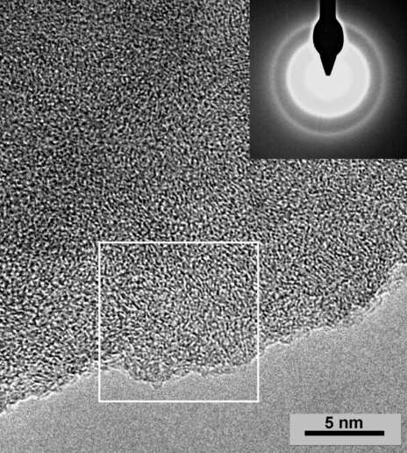

Fig. 3. Turbostratic structure and diffraction pattern of semi-anthracite. HRTEM (Duber,
2011).

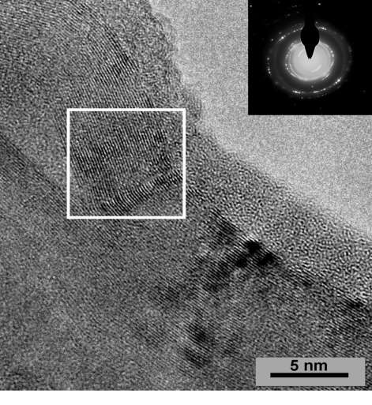
Fig. 4. Ordered structure and diffraction pattern of meta-anthracite. HRTEM (Duber, 2011).

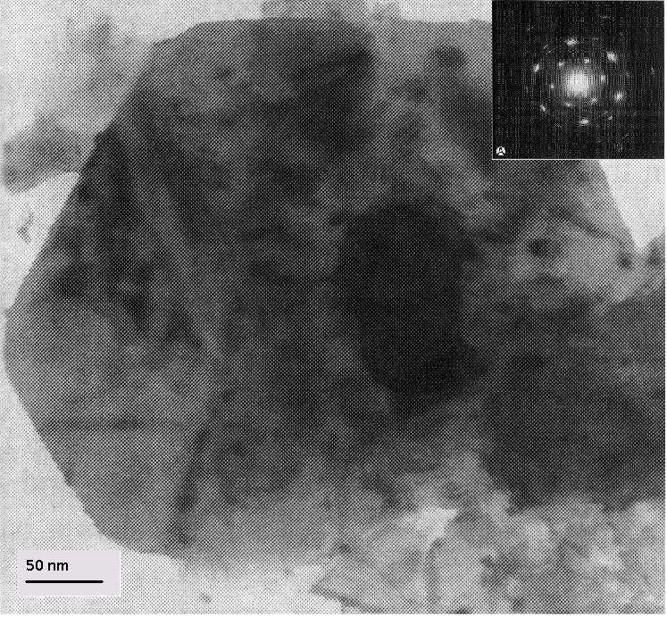

Fig. 5. Graphite flake and diffraction pattern. HRTEM. (phot. B.Kwiecińska).

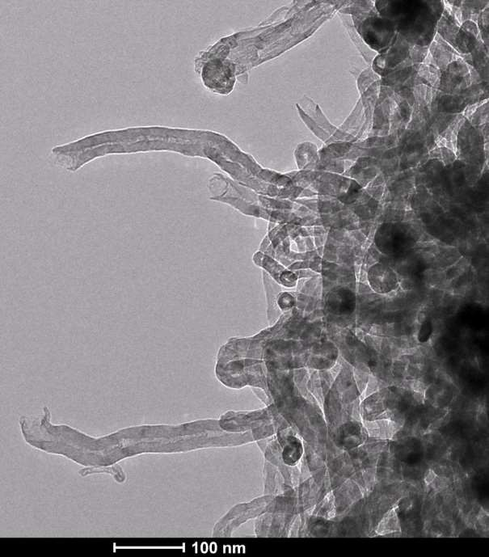

Fig. 6. Carbon nanotubes. TEM. (phot. M.Libera)

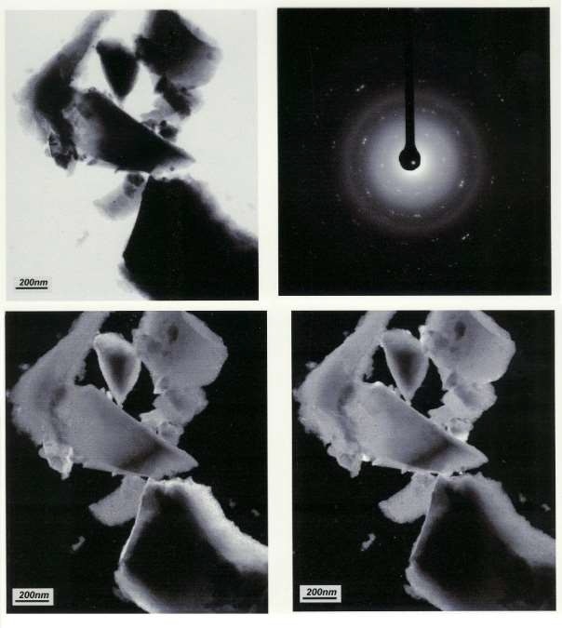
Fig. 7. Meta-anthracite thermally treated in 950 oC. TEM (phot. S.Duber),
(a) Bright Field; (b) electron diffraction pattern; (c, d) Dark Field with two different position of diaphragm (visible ordered areas – white dots).

Electron Gun

Anode

Condenser lens

Electron Beam

Scan coils

Detectors

BSE

Objective lens

SE
Amplifier
Image

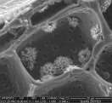

SPECIMEN

Fig. 8. Schematic drawing of scanning electron microscope (SEM).

SEM photographs (Figs 9-14)

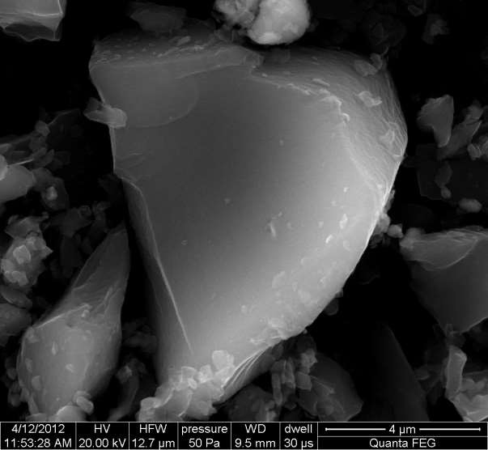

Fig. 9. Raw meta-anthracite (phot. S.Pusz).

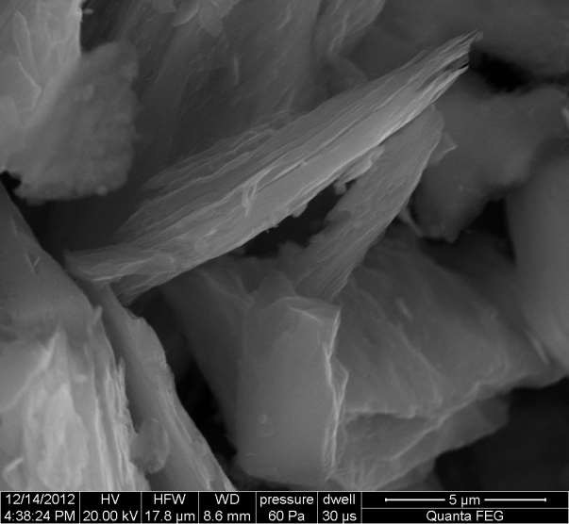

Fig. 10. Meta-anthracite thermally treated at the temperature 1700oC, in inert atmosphere (phot. S.Pusz).

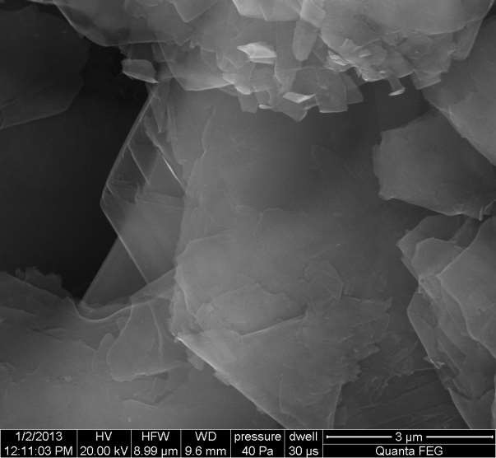

Fig. 11. Natural graphite (phot. S.Pusz).

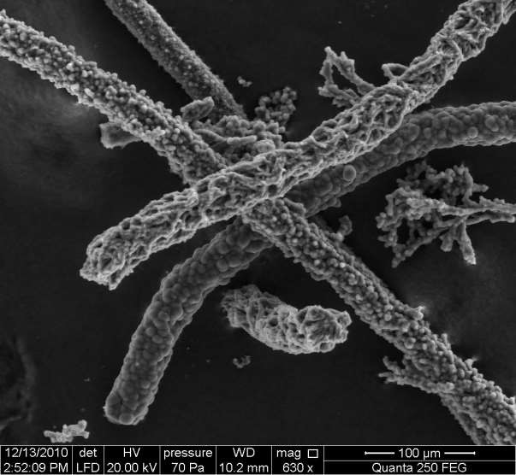

Fig. 12. Fibrous pyrolytic carbon (phot. S.Pusz).

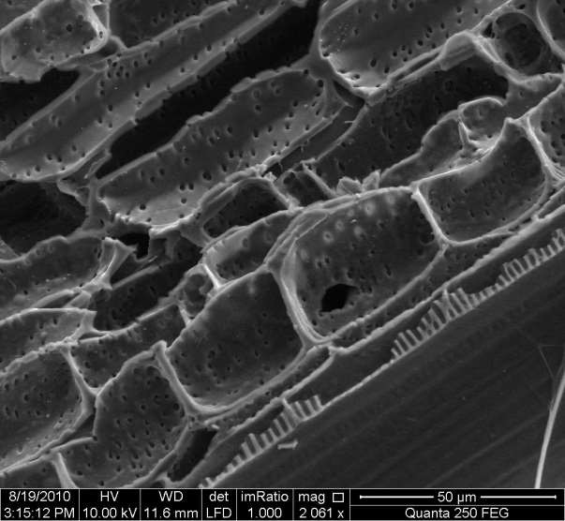

Fig. 13. Carbonized bamboo tissue (phot. S.Pusz).

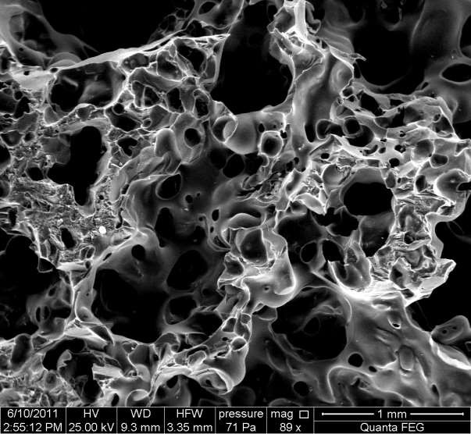

Fig.14. Carbon foam (phot. S.Pusz).

Fig. 15. Correlative images of the same field of view using optical (white and blue light) microscopy and SEM (SE and BSE modes, 5 kV, spot intensity 10, 5mm working distance) to compare different maceral types (Valentine and Hackley, 2016).

